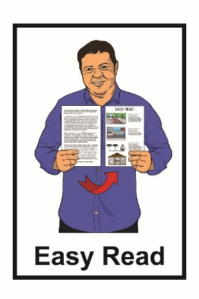

Looking at changing the law
about when adults can make
their own decisions
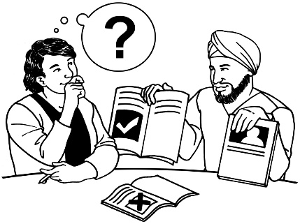

October 2021

In this document

Page number:

What is the review 2
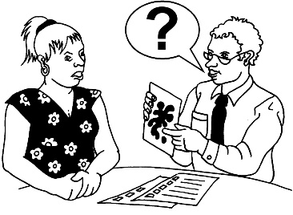

What the law is like now 7
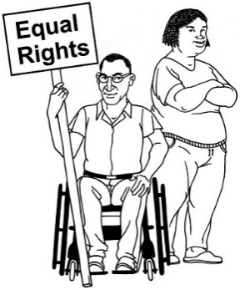

Why things need to change 11

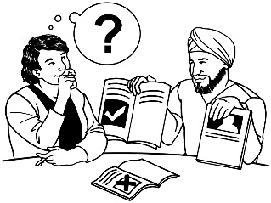
What will be part of the review 17

About the words we use 23

More information 25

What is the review

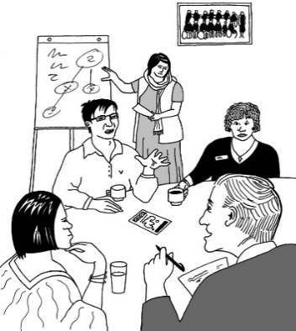
Te Aka Matua o te Ture | Law Commission is an organisation that:
- does reviews of the law
- uses what it finds out in the review to tell the government how to make the law better.

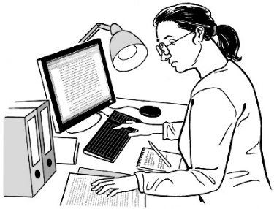

A review is when we:
- look carefully at a part of the law
- talk to people who know a lot of things to do with that part of law
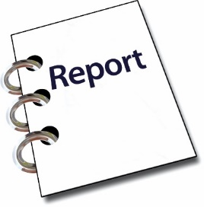
- ask people what they think
- write a report about what we have found out.

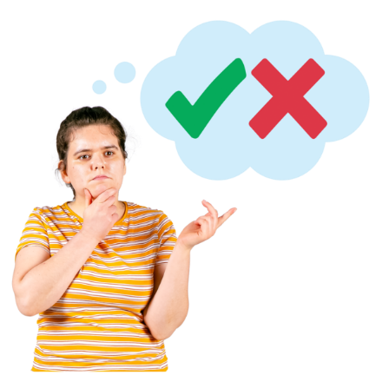
The Government asked the Law Commission to do a review about when adults can make their own decisions.

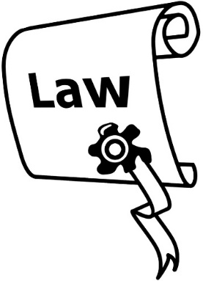
The law we have now says that some adults cannot make some decisions about their lives.

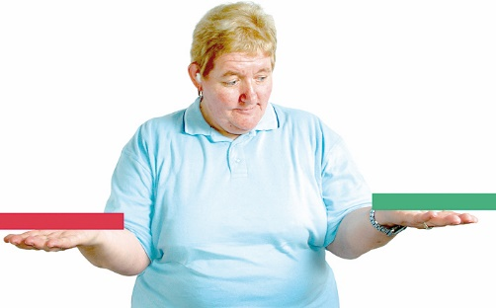
We will sometimes use the word capacity to describe when people can make their own decisions.

If people do not have capacity the law may not let them make their own decisions.

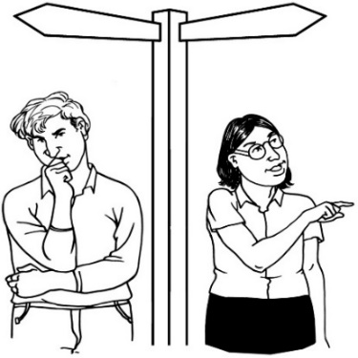
We want to make sure that the law:

lets people make decisions about their own lives as much as possible

supports people to make their own decisions

keeps people safe.

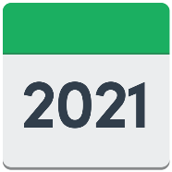
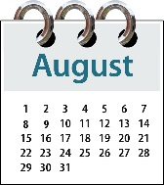
The review started in October 2021.

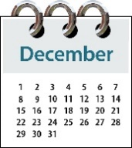
The Commission plans to report to the Minister of Justice by the end of 2023.

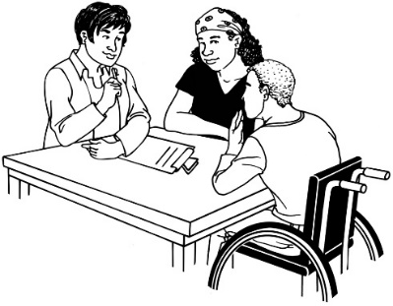
Reporting means telling the Minister what:
- we have found out
- our ideas are.
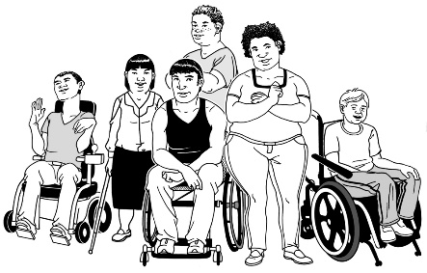

We will work with:
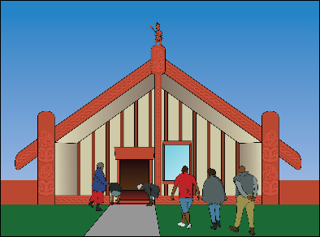
- disabled people
- tāngata whaikaha / Māori disabled people
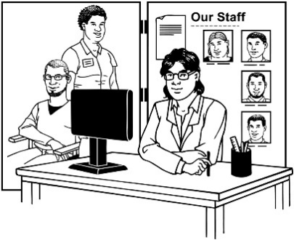
- organisations that represent disabled people.

Some of the things we will work together on are to make sure:
- disabled people and communities can be part of the review as much as possible
- we ask people what they think in ways that are accessible to disabled people.
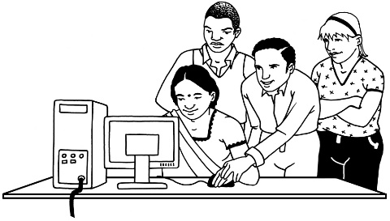

Accessible means in ways that work well for disabled people.

What the law is like now

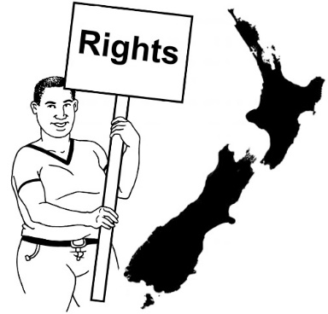
The main law that talks about adults being able to make decisions is the Protection of Personal and Property Rights Act 1989.

This law is also called the PPPR Act.

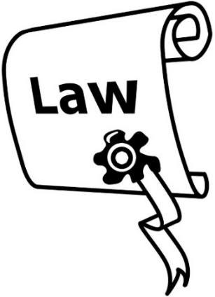
There are other laws that cover things to do with being able to make decisions.

These cover a lot of different decisions people might make in their lives.

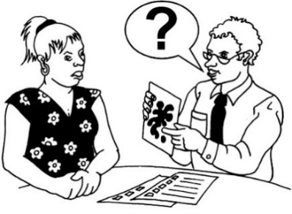
The law now says that if a person does not have capacity the decisions they make may not need to be followed by the law.

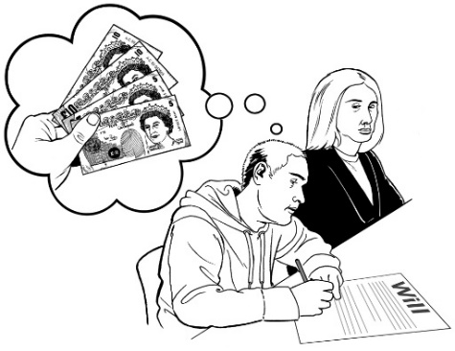
For example if they say who they want to get their money when they die the law may not have to follow this.

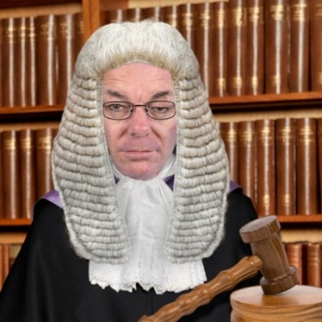
The law can say someone else can make decisions for them.

This person is called a substituted decision-maker.
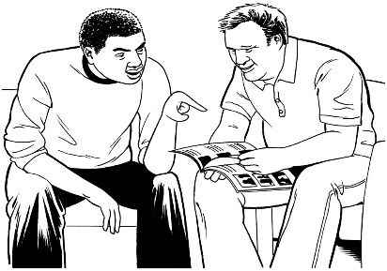

When another person makes decisions for someone this is called substituted decision-making.

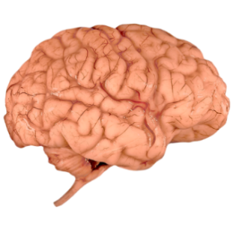
People who might have decisions made for them include some people:
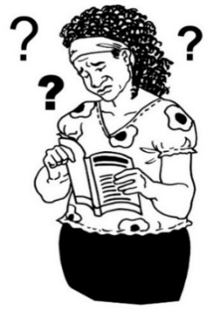
- who have brain injuries
- who have dementia
- with learning disability
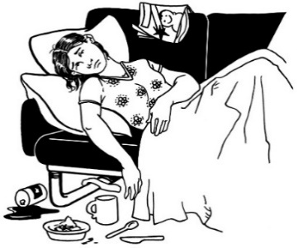
- with mental health needs
- who have other conditions or disabilities that affect how they make decisions.

Dementia is a condition where people find it harder to:
- remember things
- understand things.
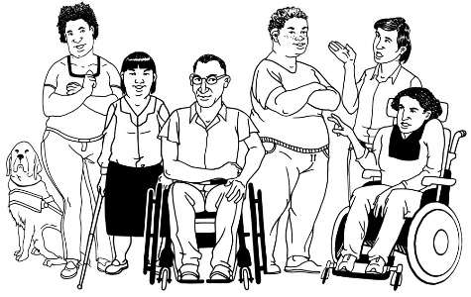
People are sometimes in more than 1 of these groups.

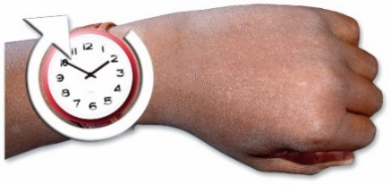
How easily someone can make decisions can be different at different times.
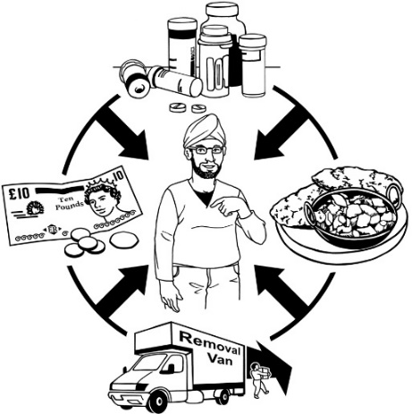

It can also be different for different kinds of decisions.

Why things need to change

Lots of things have changed since the PPPR Act become a law more than 30 years ago.

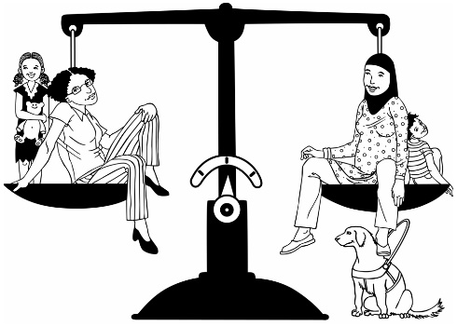
There have been:
- problems with the law
- big changes in how people think about disability.

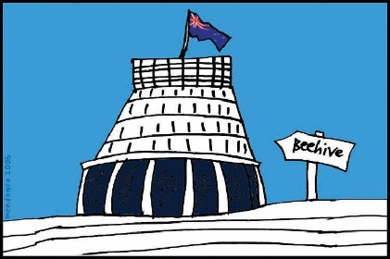
In 2008 the New Zealand Government said that we agree with the United Nations Convention on the Rights of Persons with Disabilities.

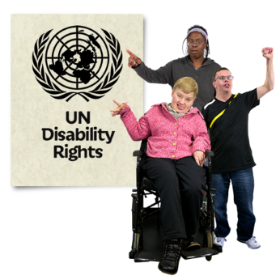
The United Nations Convention on the Rights of Persons with Disabilities is a law lots of countries have agreed to.

The United Nations Convention on the Rights of Persons with Disabilities is also called the UNCRPD.
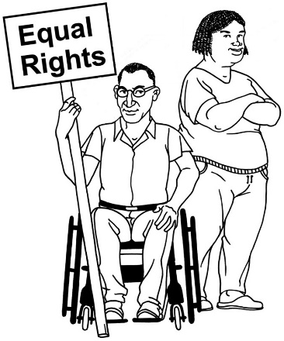

The UNCRPD says what governments must do to make sure disabled people get the same rights as everybody else.

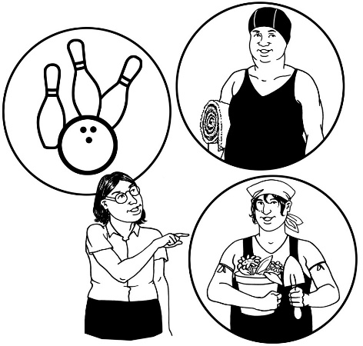
The UNCRPD says that:
- disabled people have the right to be part of decisions that affect them
- the government has to support disabled people to use this right.
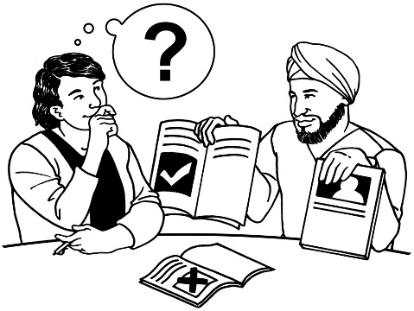

This is can also be called supported decision-making.

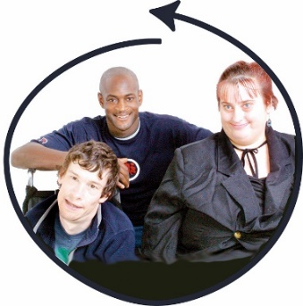
The UNCRPD also says that disabled people have a right to be part of work on making laws that affect them.

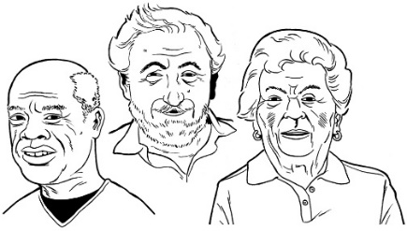
Another reason things need to change is that there are going to be more older people in New Zealand.

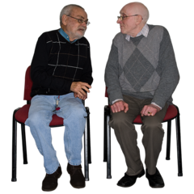
This means more people will need support to make decisions about their lives.

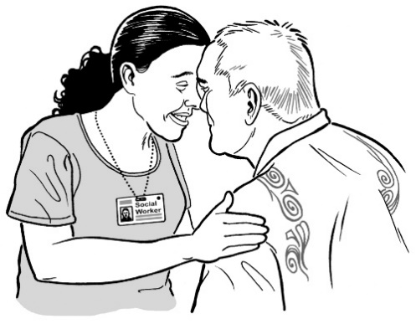
The PPPR Act may not be a good fit with:

- Māori ideas about the world
- the rights of tāngata whaikaha / Māori disabled people

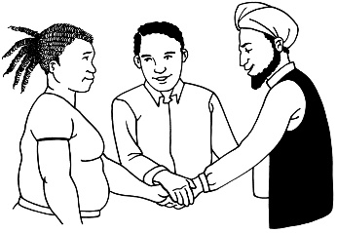
The New Zealand Disability Strategy Whakanui Oranga says how all the parts of government will work on things to do with disability.
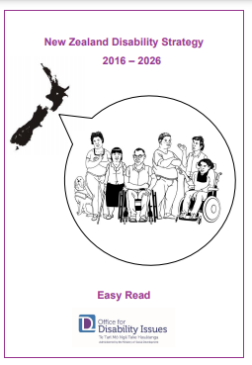

We also call The New Zealand Disability Strategy Whakanui Oranga the Strategy.

There is an Easy Read translation of the Strategy at:
https://bit.ly/35WnuzE

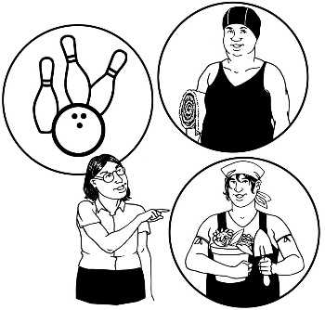
The Strategy says that:
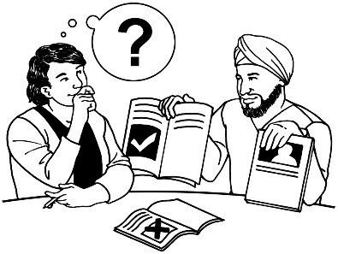
- disabled people must be part of the decision-making that affects them
- people who need support to make or communicate decisions should get that support
- there should be safeguards that protect people who need support when they use their rights.

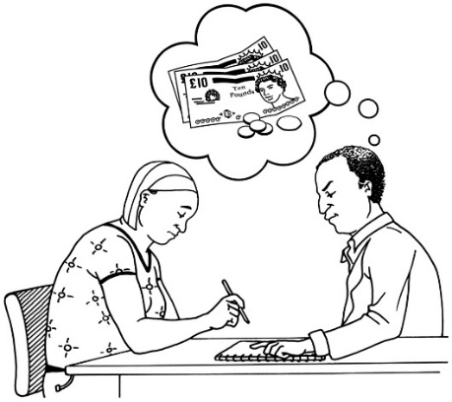
Safeguards are things that work to protect people from things like:
- being hurt
- being tricked out of their money.

What will be part of the review
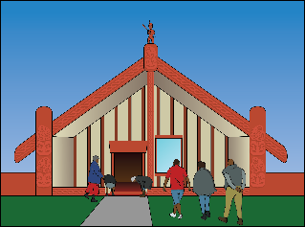

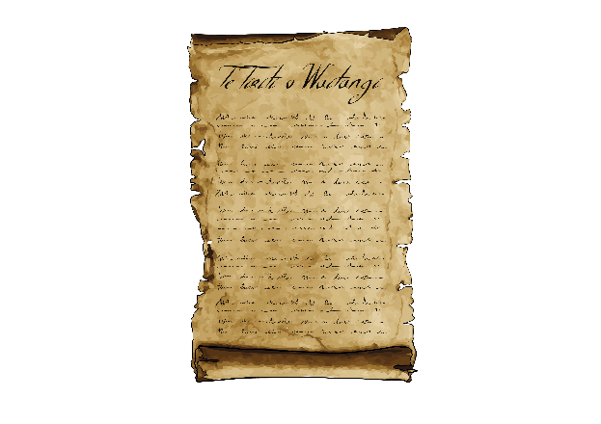
Some of the things that will be part of the review are:
- Māori perspectives
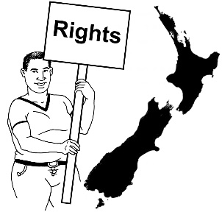
- how law should fit with te Tiriti o Waitangi / the Treaty of Waitangi
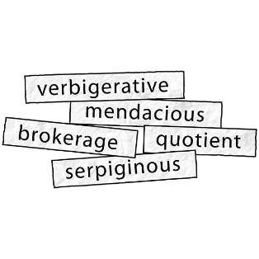
- how the law should make sure everyone has their human rights protected
- the words used in the law
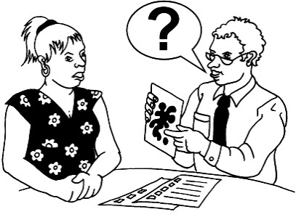
- how to find out if people have capacity.

The review will look at how the law should:
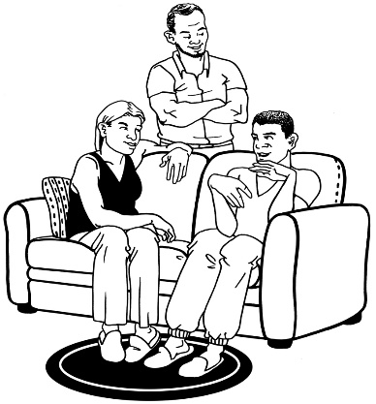
- make sure people who need decision-making support get it
- recognise how other people like whānau / family are part of that support.

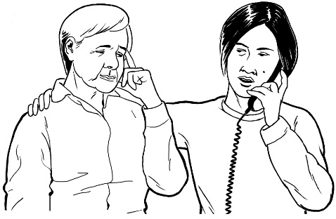
The review will look at the rules the law should set up about:
- times when decisions may need to be made for another person
- when people who find it hard to make decisions are not allowed to:
  - go places they want to
  - leave where they live.

The review will also look at what safeguards should be in the law.

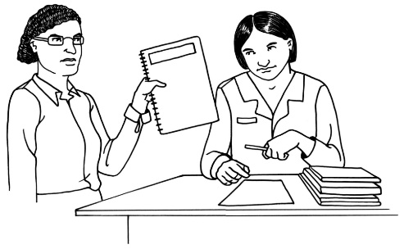
The review will also look at other laws that affect decision-making.

The review will look at these laws to see how they fit together.

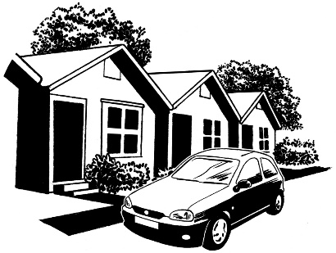
Some of the laws being reviewed are:
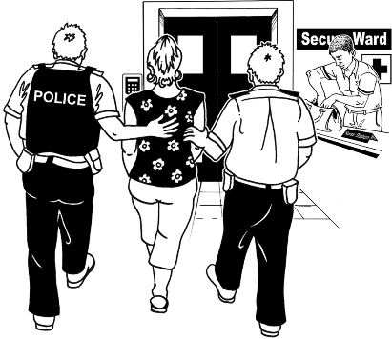
- Protection of Personal and Property Rights Act 1988 / PPPR Act.
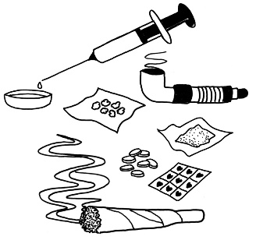
- Mental Health (Compulsory Assessment and Treatment) Act 1992
- Substance Addiction (Compulsory Assessment and Treatment) Act 2017
- Health and Disability Commissioner Act 1994.

The Government is also doing reviews of 2 of these other laws:

- Mental Health (Compulsory Assessment and Treatment) Act 1992
- Substance Addiction (Compulsory Assessment and Treatment) Act 2017.

We will think about how these other reviews affect this review.

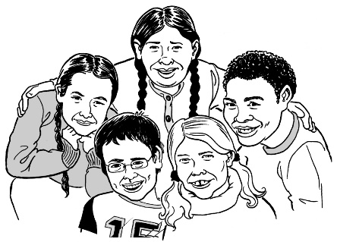
We will not review decision-making capacity in:
- children
- law to do with crimes.

Crimes are things you can get arrested for like:
- stealing
- hitting someone.

We may still say something about how our review might affect capacity in:
- children
- law to do with crimes.

About the words we use

The words we use about disability are important.

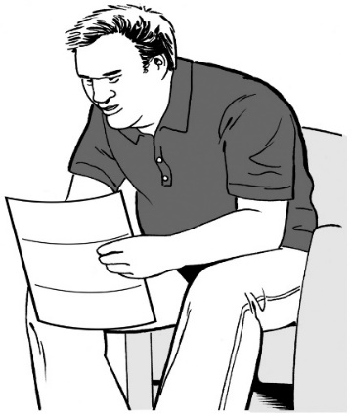
Different people prefer different words.

Some people understand words differently to others.

What words people use most changes over time.

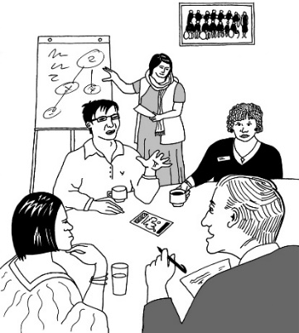
The words used in the law are part of this review.

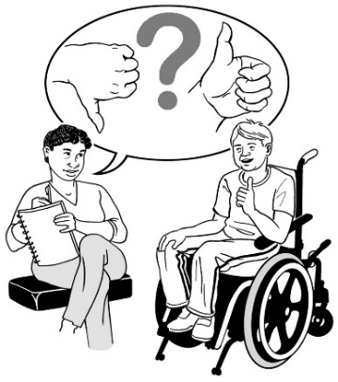
We will be asking what disabled people think about the words used in the law.

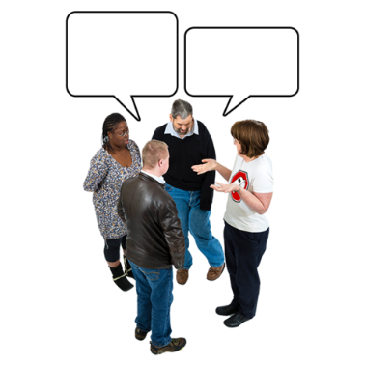
English is an official language in New Zealand.

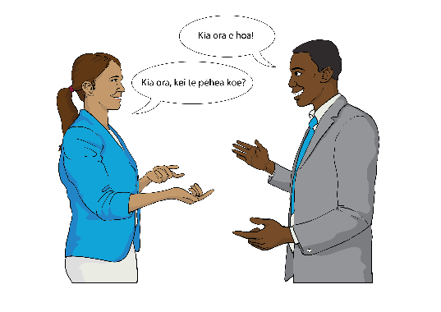
New Zealand has 2 other official languages:
- te reo Māori
- New Zealand Sign Language.

It is important that we use these languages as much as we can when we do our review.

More information
You can find more information on our website at:

https://www.lawcom.govt.nz
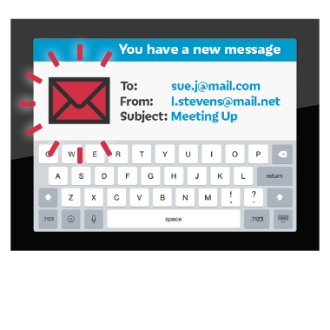

You can sign up to be emailed updates as the review happens at:

https://www.huarahi-whakatu.lawcom.govt.nz

This information has been written by the Law Commission.
It has been translated into Easy Read by the Make It Easy service of People First New Zealand Inc. Ngā Tāngata Tuatahi.
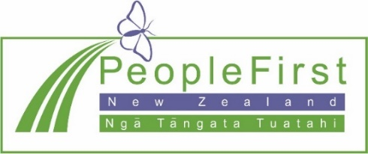
The ideas in this document are not the ideas of People First New Zealand Inc. Ngā Tāngata Tuatahi.
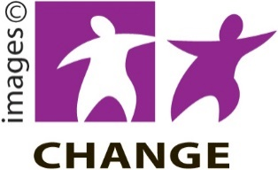
Make It Easy uses images from:
- Changepeople.org
- Photosymbols.com
- Sam Corliss

All images in this Easy Read document are subject to copyright rules and cannot be used without permission.

