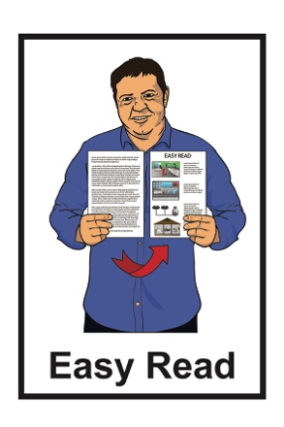

He Arotake i te Ture mō ngā Huarahi Whakatau a ngā Pakeke

Review of Adult Decision-Making Capacity Law

Summary of Preliminary Issues Paper

November 2022

In this document

Page number:

What is this review? 3

What is this review about? 5

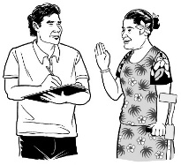
Telling us what you think 9

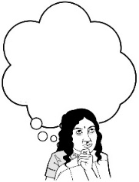
What we will do with
your submission 12

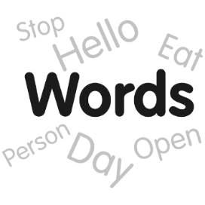
How we will use words
in the review 15

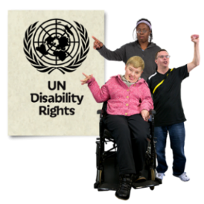
Why things need to change 18

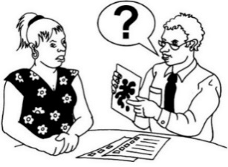
Page number:

What the law is like now 24
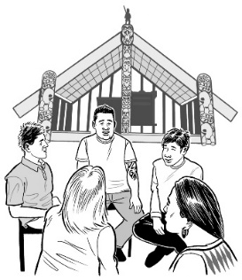

Te Ao Māori / Tikanga Māori 26

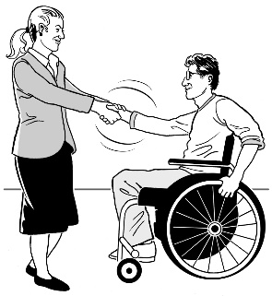
Guiding principles for the review 32

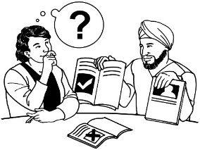
What kinds of decision making
are we thinking about? 35

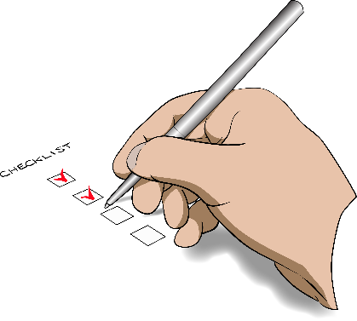
Safeguards and accountability 44

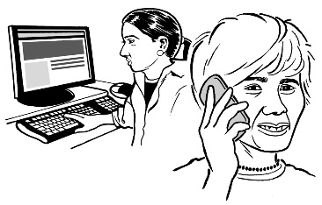
Is there anything else you would
like to tell us? 50

What is this review?

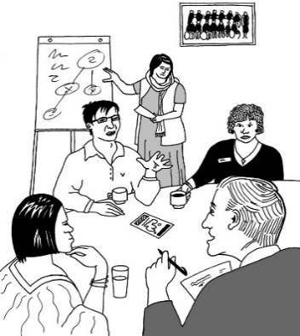
Te Aka Matua o te Ture | Law Commission is an organisation that:
- does reviews of the law
- uses what it finds out in the reviews to tell the Government how to make the law better.

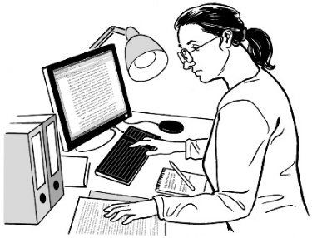

A review is when we:
- look carefully at a part of the law
- talk to people who know a lot of things to do with that part of law
- ask people what they think
- write a report about what we have found out.

The Government asked the Law Commission to do a review about when adults can make their own decisions.

As part of this review the Law Commission has written a document called:

He Arotake i te Ture mō ngā Huarahi Whakatau a ngā Pakeke / Review of Adult Decision-Making Capacity Law - Summary of Preliminary Issues Paper.
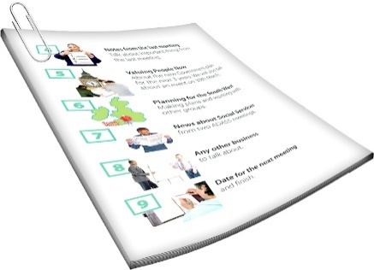

This Easy Read document is about the main things in the document.

In this Easy Read document when we say we this means the Law Commission.

What is this review about?
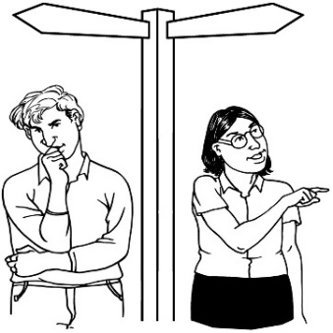
Some people find it hard to make decisions about their own lives.

In this document we will call people who find it hard to make decisions about their own lives people with affected decision making.
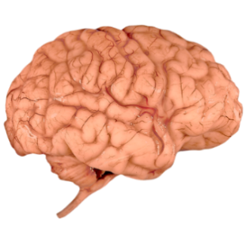

People with affected decision making include some people who have:
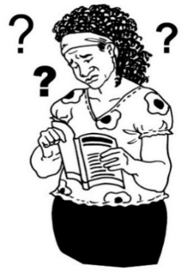
- brain injuries
- dementia
- learning disabilities

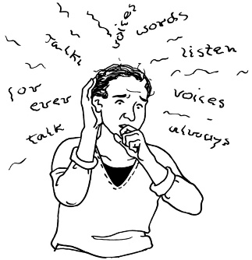
- experiences of mental distress

- other conditions or disabilities that affect how they make decisions.
Dementia is a health condition where people can find it hard to:
- remember things
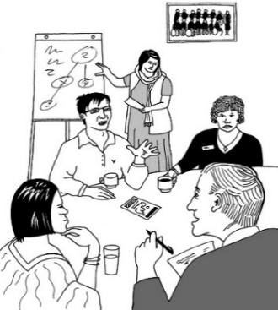
- understand things.

In this review we are looking at what the law should do when people have affected decision making.

The law we have now says that some adults cannot make some decisions about their lives.

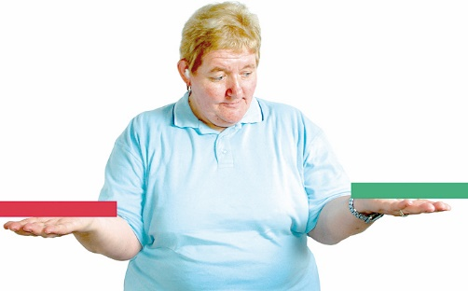
The law we have now sometimes uses the word capacity to describe when people can make their own decisions.

If people do not have capacity the law may not let them make their own decisions.
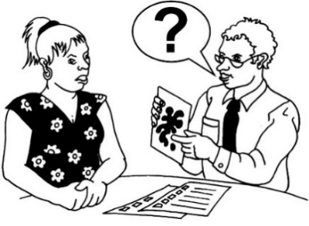
The law now says that if a person does not have capacity some decisions they make may not need to be followed by the law.

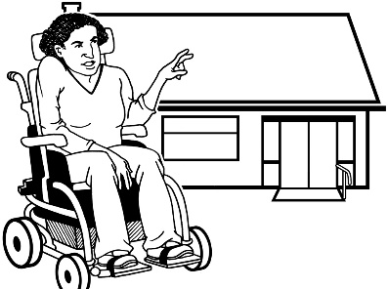
For example if they say they want to live in their own home the law may not follow this.
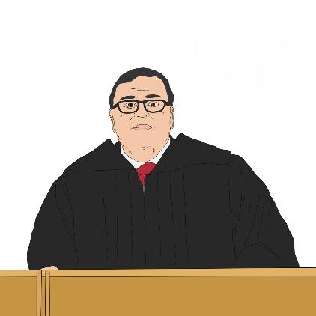

The law can say someone else can make decisions for people who do not have capacity.

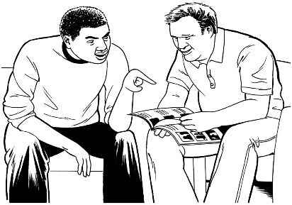
This person is called a substituted decision maker.

When another person makes decisions for someone this is called substituted decision making.

Lots of people think the law needs to change.

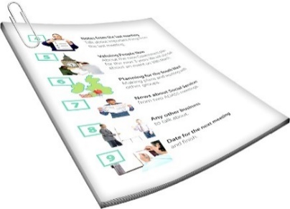
There is an Easy Read document that says what things are part of our review.

This document is called the Terms of Reference.

You can find this document on our website at:

https://huarahi-whakatau.lawcom.govt.nz/wp-content/uploads/2022/11/Nga-Huarahi-Whakatau-Terms-of-Reference-Easy-Read.pdf

Telling us what you think
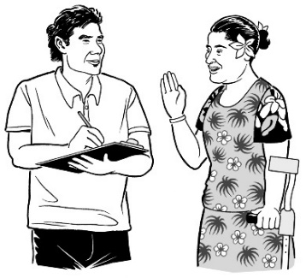

We want to hear what you think.

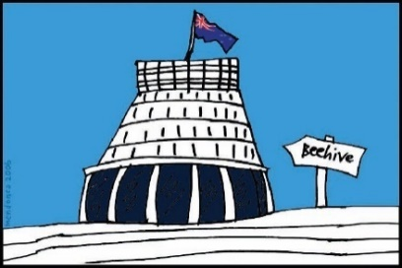
What you tell us will be used as part of deciding what to tell the Government we think the law should be.

Telling us what you think is called making a submission.

In this document there are questions about different things we will think about in the review.

When you make your submission you can answer:
- all the questions
- just the questions you want to.

You need to get your submission to us by:

5 pm Friday 3 March 2023.

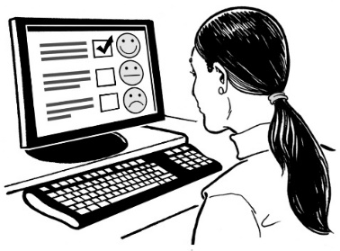
You can make a submission by answering questions on our project website at:

https://huarahi-whakatau.lawcom.govt.nz

You can also make a submission by:

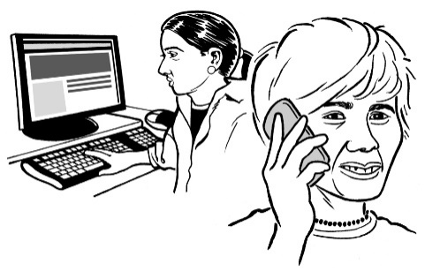
- sending us an email at:
huarahi.whakatau@lawcom.govt.nz
- texting us on
029 77 99 009

You can also post your submission to:

Review of Adult Decision Making Capacity Law

Law Commission

PO Box 2590

Wellington 6140

What we will do with your submission
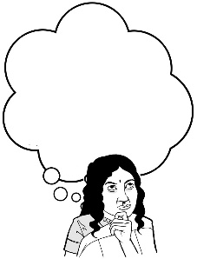
If you send us a submission we will:

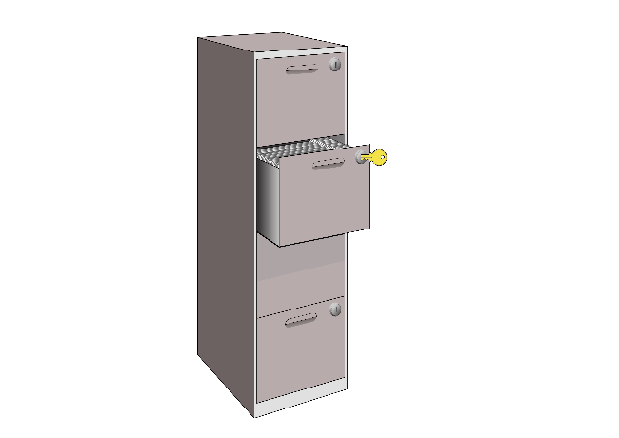
- think about what you said when we do the review
- keep the submission as part of our records.

If you send us a submission we may also:

- put the submission on our website
- talk about the things you said in things we write
- think about your submission when doing other reviews.

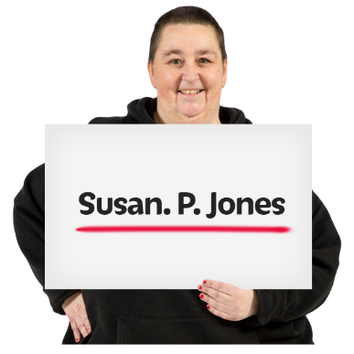
Your submission may have personal information like your name.

You have the right to:
- see what personal information we have about you
- ask us to change any wrong personal information.

You can ask that we do not tell anyone:
- your name
- other information that means people can tell who you are.

If someone asks us for information under the Official Information Act we have to follow the rules about releasing it.

The Official Information Act is a law that lets people see information the Government has.

If the information someone is asking for includes personal information like your name then we will talk to you.

Another law we follow when using your information is the Privacy Act.

If you have questions about what we do with your submission / information you can email:

gm@lawcom.govt.nz

How we will use words in the review

The words we use are important.

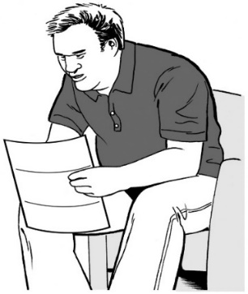
Different people prefer using different words.

Some people understand words differently to others.

What words people like to use changes over time.

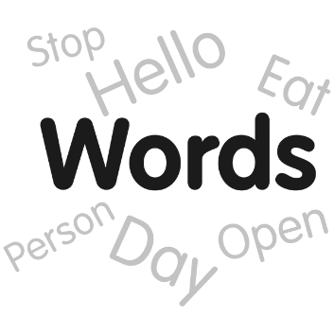
We will need to decide what words to use in our review so what we write is clear.

We want to know what you think about the words we use.
When talking to people on their own we will try to use the language they want to use.

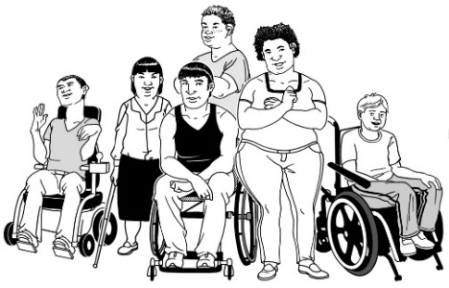
These are some important words we may use in our documents:
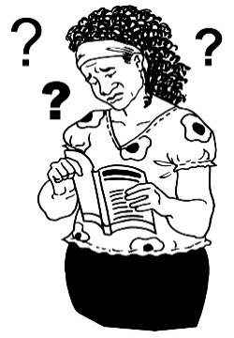
- disabled person not person with a disability
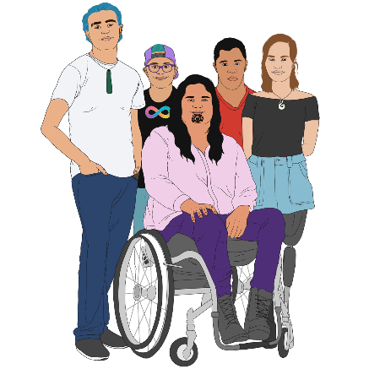
- learning disability not intellectual disability / cognitive impairment
- tāngata whaikaha Māori to mean Māori disabled people
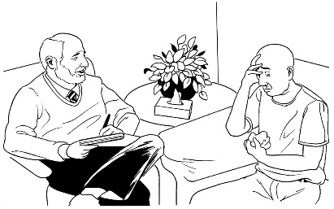
- person experiencing mental distress not person with mental health needs / mental illness / mental disorder.

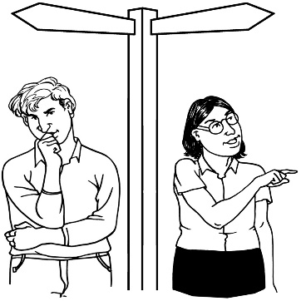
When we talk about adults to have affected decision making we say they have personal lived experience.

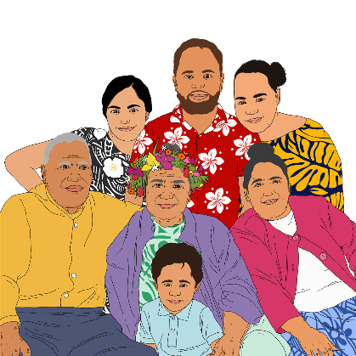
When we talk about family / whānau / friends / carers of someone who has personal lived experience we say they have lived experience as a family member / whānau member / friend / carer.

Question 1

Do you agree with us using these words in our review?

If not what changes should we make?

Why things need to change

Lots of things have changed since the current law about making decisions was created.
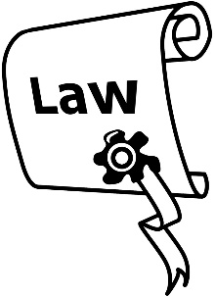

One of the main laws in this area is the PPPR Act.

The PPPR Act is also called the Protection of Person and Property Rights Act.
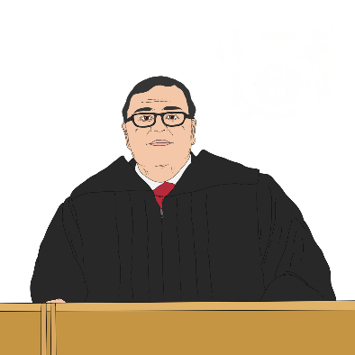

PPPR Act allows a Court judge to appoint someone to protect the personal and property rights of a person with affected decision making.

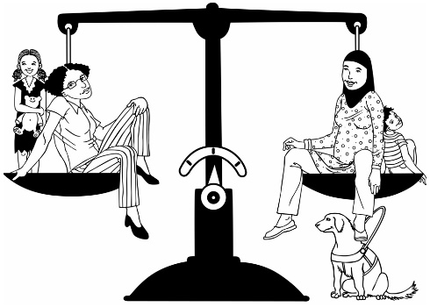
There have been:
- problems with the way the law works
- big changes in how people think about disability.

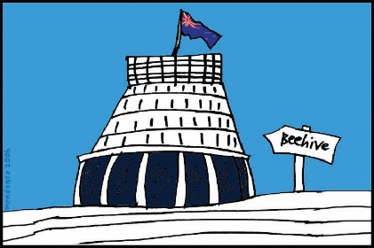
In 2008 the New Zealand Government said that we agree with the United Nations Convention on the Rights of Persons with Disabilities.

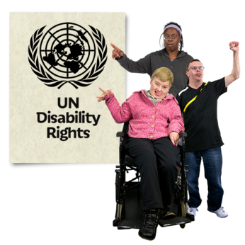
The United Nations Convention on the Rights of Persons with Disabilities is a document lots of countries have agreed to.

The United Nations Convention on the Rights of Persons with Disabilities is also called the UNCRPD.

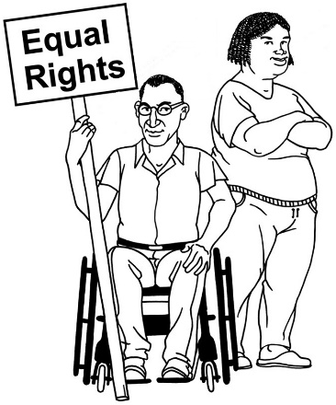
The UNCRPD says what governments must do to make sure disabled people get the same rights as everybody else.

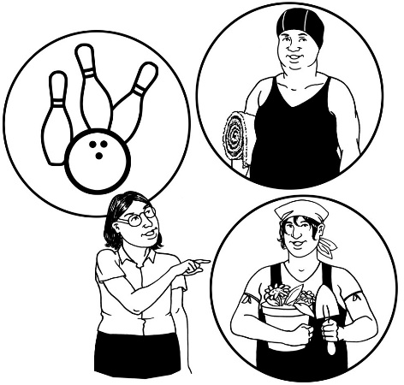
The UNCRPD says that:
- disabled people have the right to make their own decisions
- the Government has to make sure that disabled people are able to get the right support they need to use this right.
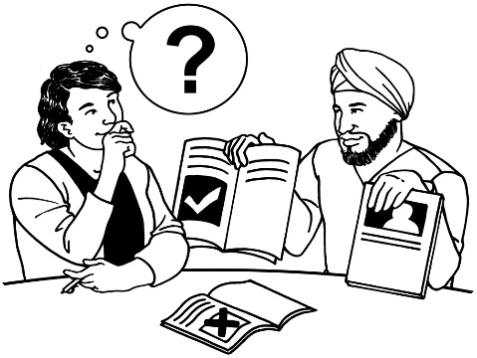

This can be called supported decision-making.

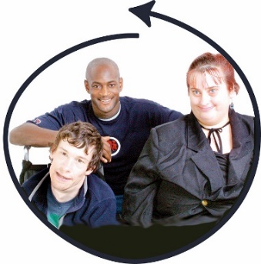
The UNCRPD also says that disabled people have a right to be part of work on making laws that affect them.

People also understand more about:
- what decision making means
- how people can be supported to make decisions.

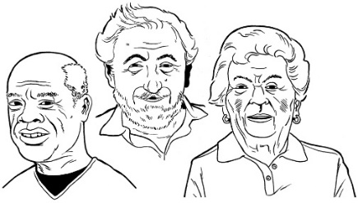
Another reason things need to change is that there are going to be more older people in New Zealand.

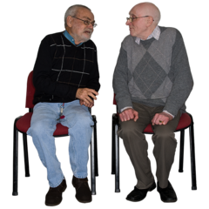
This means more people will need support to make decisions about their lives.

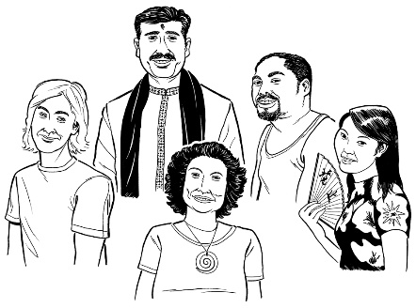
There are people from lots of different cultures in New Zealand.

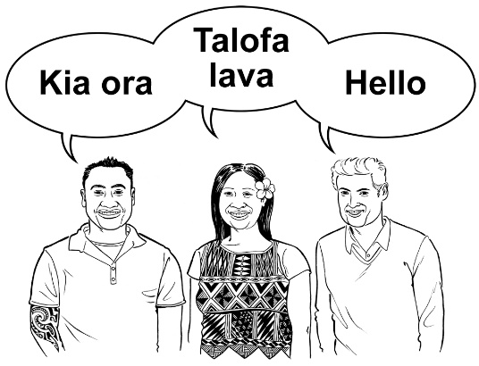
Culture is a word that means things like:

- beliefs / traditions that a group shares

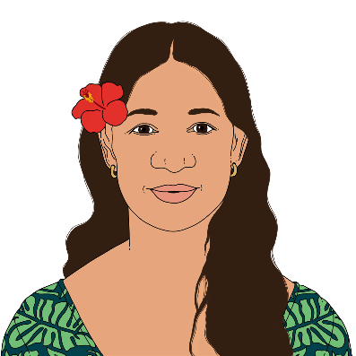
- ways of doing things within a group.

It is important these cultures are thought about when making the law.

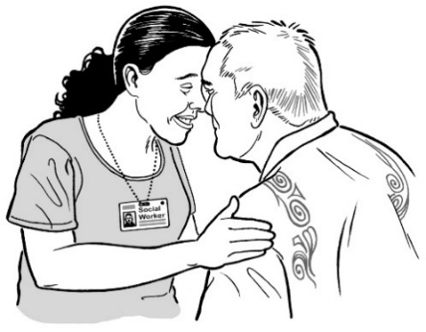
The law we have now may not be a good fit with:

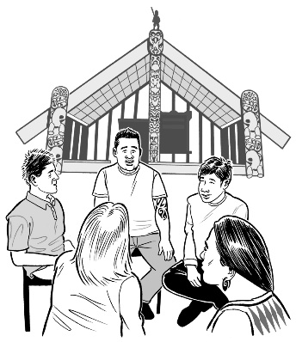
- Māori ideas about the world
- the rights of tāngata whaikaha / Māori disabled people
- te Tiriti o Waitangi / the Treaty of Waitangi.

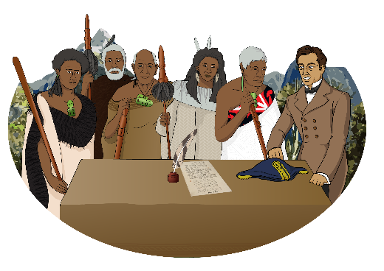
Te Tiriti o Waitangi / The Treaty of Waitangi is an important agreement between Māori and the Crown.

What the law is like now
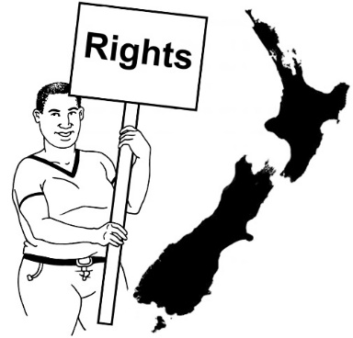
In New Zealand there are lots of laws that say things about decision making.

Some of these laws are:
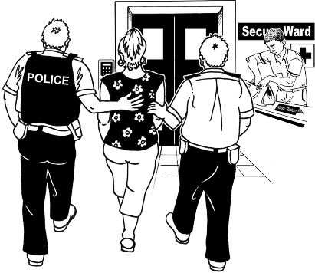
- Protection of Personal and Property Rights Act 1988 / PPPR Act
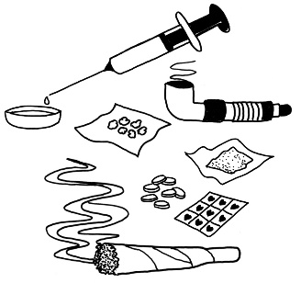
- Mental Health (Compulsory Assessment and Treatment) Act 1992
- Substance Addiction (Compulsory Assessment and Treatment) Act 2017
- Code of Health and Disability Services Consumers' Rights.

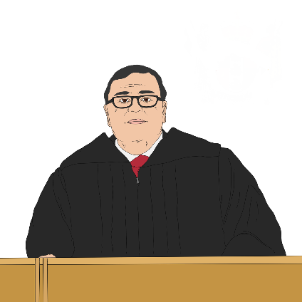
There are also things about decision making in the common law.

The common law is law that comes from what has been decided in court.

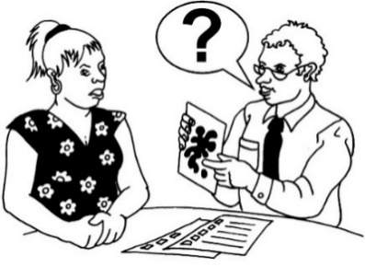
All these laws work from the idea that some people do not have capacity to make some decisions.

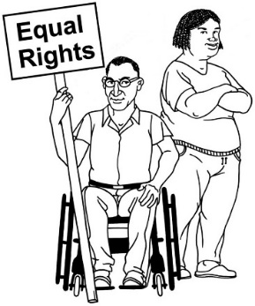
There are other kinds of law that are important for us like human rights.

Te Ao Māori / Tikanga Māori

We are thinking about:
- tikanga Māori which can mean Māori ways of doing things
- Māori concepts that are important to adult decision making.

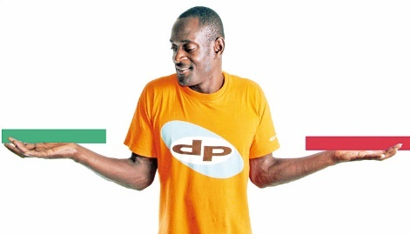
The idea of decision-making capacity is based on thinking about people deciding things alone.

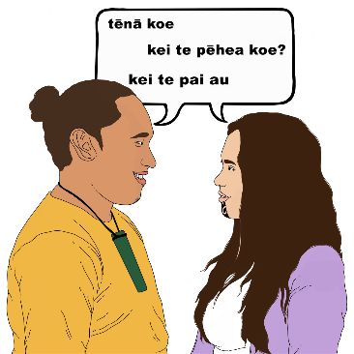
Māori ways of thinking about decision making might involve people deciding things together rather than by themselves.

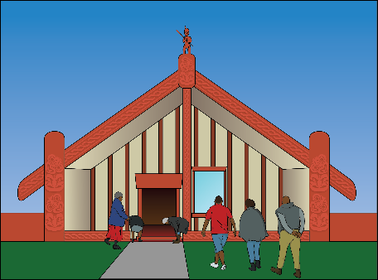
We are thinking about 6 tikanga that may be important to decision making in te ao Māori / the Māori world.

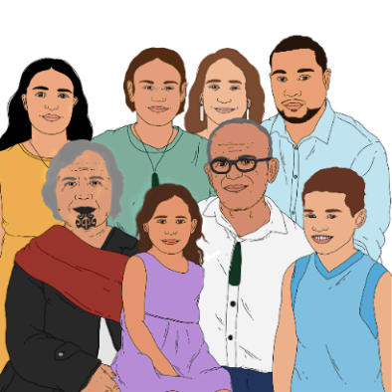
- Whanaungatanga is about:

  - close connections between people

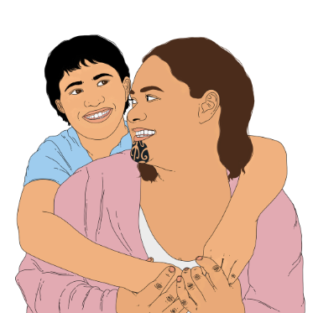
  - how whānau / hapū / iwi may be involved in a decision

- Aroha means things like love / caring for others
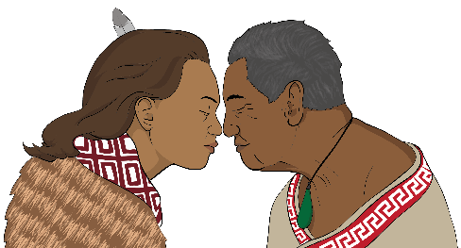
- Mana is about the respect / importance that someone can have

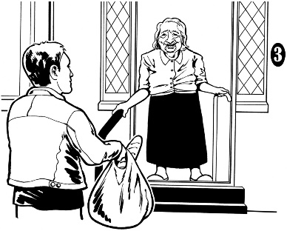
- Tiaki is about caring for people / things that are important.

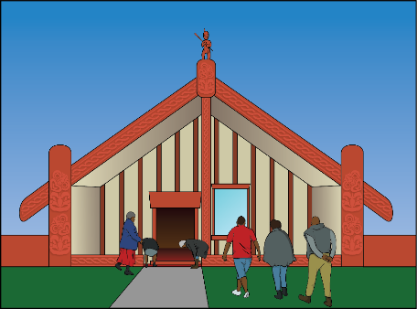
Some more of the 6 tikanga Māori that may be important to decision making in te ao Māori / the Māori world:

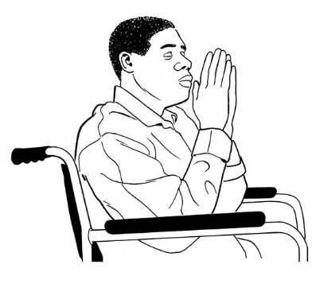
- Wairua is:

  - something similar to the spirit of a person

  - related to the mauri / life force that people can have

- Rongo is about people being balanced.

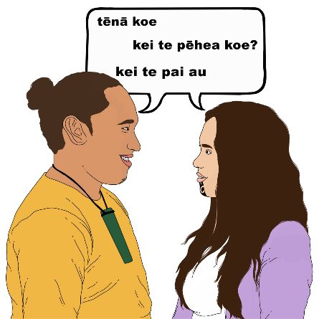
We also thought about 3 te reo Māori words that can be important when people make decisions.

These 3 te reo Māori words involve things like ideas / feelings / spirits.

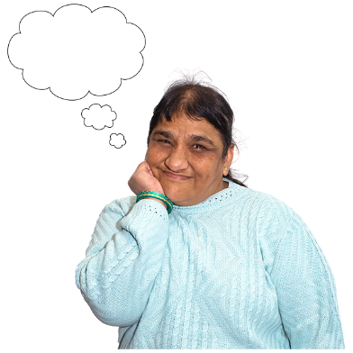
- Hinengaro is to do with:

- your mind

- how a person thinks / feels

- Wairangi is someone who is confused or has trouble making decisions
- Pōrangi means someone who is always finding things very hard and cannot make decisions.

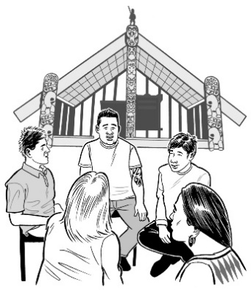
We understand that these ideas and concepts from tikanga Māori / te ao Māori are more important for some people than for others.

Question 2
Are 6 tikanga Māori / 3 te reo Māori words we listed the most important ones for decision making?

If not what changes should we make?

Question 3

How is tikanga Māori important to you in decision making?

Question 4
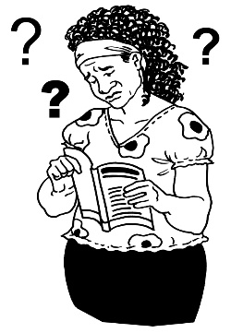
This question is about times when someone has had affected decision making.

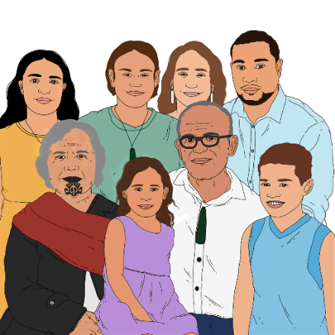
In these times have you and your whānau / hapū / iwi been able to act in a way that fits with tikanga Māori in a way you want?

If not how could things have been better?

Guiding principles for the review

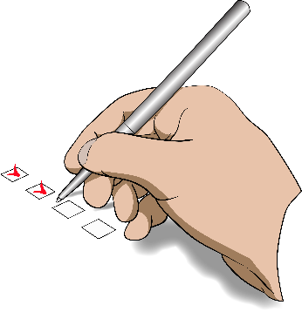
We have some guiding principles for the review.

Guiding principles are the important ideas that we use to check our thinking about what the law should be.

Our guiding principles are that we think the law about adult decision making should:
- respect the human rights of people with affected decision making

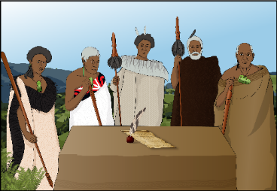
- follow the things the Crown needs to do under te Tiriti o Waitangi.
Some more of our guiding principles are that we think the law about adult decision making should:

- accept / make space for the things needed for tikanga Māori

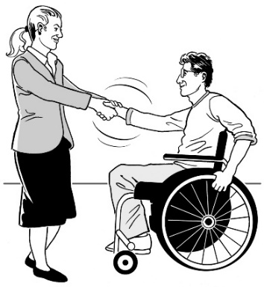
- mean people who may find it hard to make decisions can live good lives

- support relationships that are based on trust

- keep people safe

- be accessible.

Having a law that is accessible means there is a good balance between:
- having the same rules for everyone

and
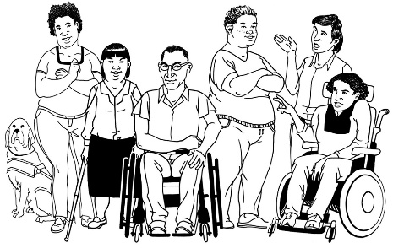
- making changes to the law that fits with the different needs of people.

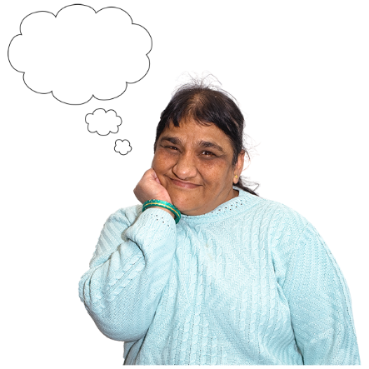
Question 5

Do you agree with the 7 guiding principles we have made?

If you do not agree what changes should we make?

What kinds of decision making are we thinking about?

There are lots of different ways people make decisions.

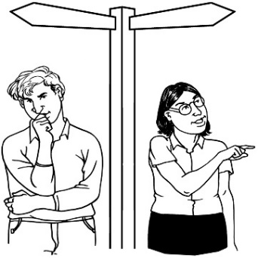
Often people with affected decision making have other people involved in their decision making.

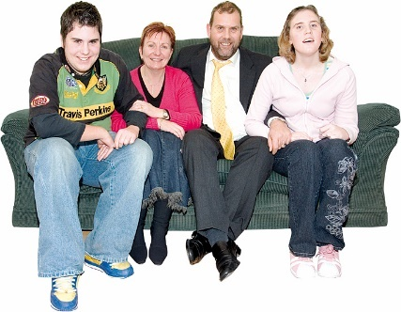
This can be:
- informal like friends / family just stepping in to support someone

- formal like when a court says how these people should be involved.

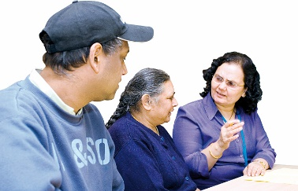
We have heard that informal decision making can be hard for supporters because they cannot do some things.

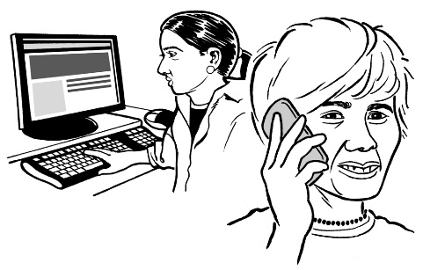
For example they cannot get organisations to give them information about the person they are supporting.

Question 6

Has someone supported you to make a decision?

Have you supported a person with affected decision making to make a decision?
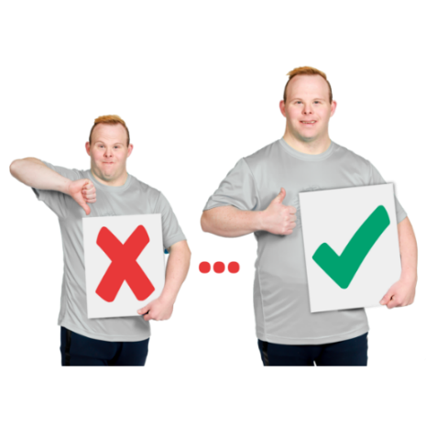

If yes how do you think things went?

What could have gone better?

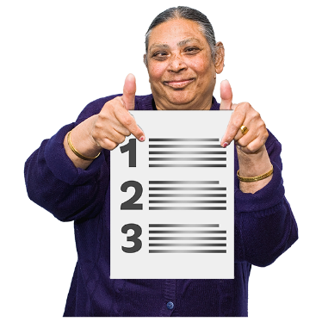
Advance directives are when a person says what they want to happen in the future such as if they become unwell.
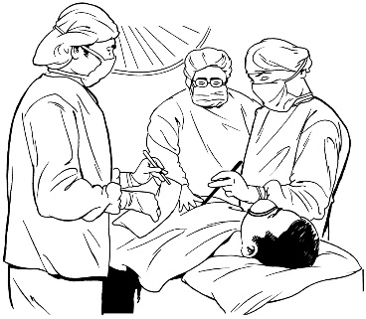
For example they may say what medical treatment they want if they become too unwell to decide.
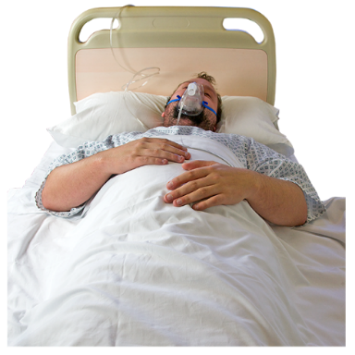
Question 7

Have you been part of making or using an advance directive?

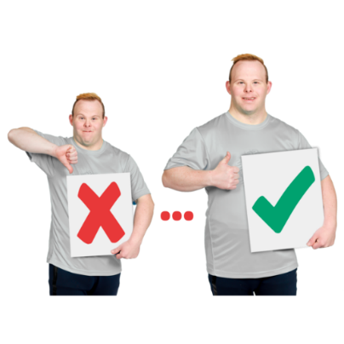
If so how do you think things went?

What could have gone better?

Enduring powers of attorney are when a person says who they want to make decisions for them in the future if they are not able to.

Question 8
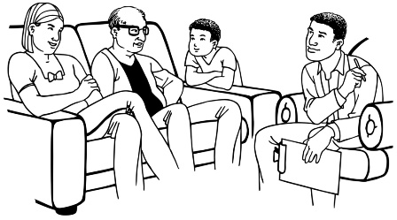

Have you been part of making or using an enduring power of attorney?
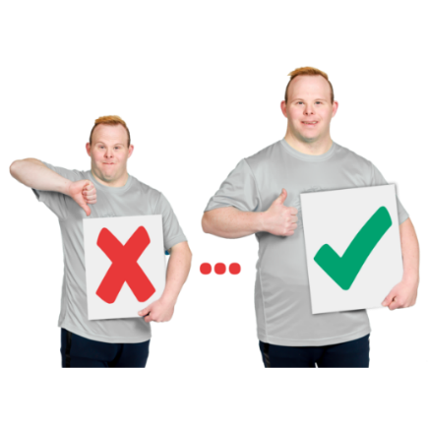

If so how do you think things went?

What could have gone better?

A court order can:
- make decisions for someone with affected decision making like where they live
- choose someone else to make decisions for that person.

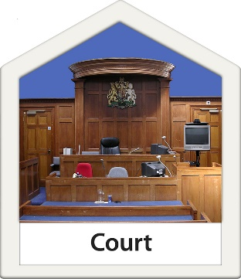
These kinds of court orders can only be made for someone who does not have capacity under the current law.

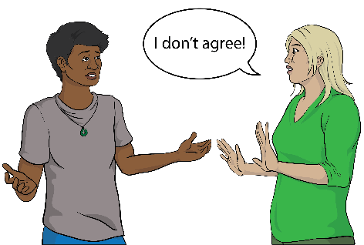
They can be made without the person agreeing to them.

Question 9

Have you been part of:
- making decisions for someone else as part of a court order
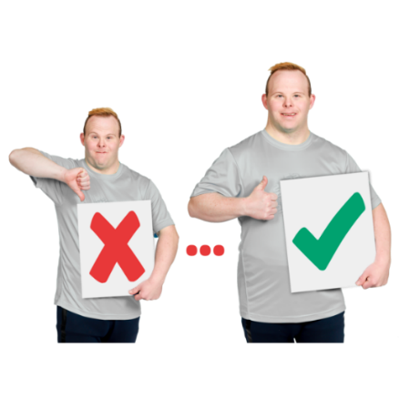
- having someone else make decisions for you as part of a court order?

If yes how did it go?

What could have gone better?
Some people think the law should include collective ways of making decisions.

Collective means people working together.

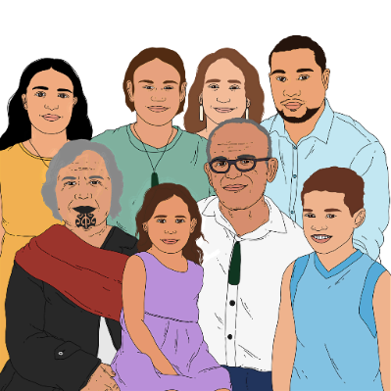
This could mean things like:
- family / whānau being part of making decisions
- people making decisions together with a person with affected decision making.

Question 10

Do you think there should be more ways for people to be part of decision making?

If yes what are these ways?

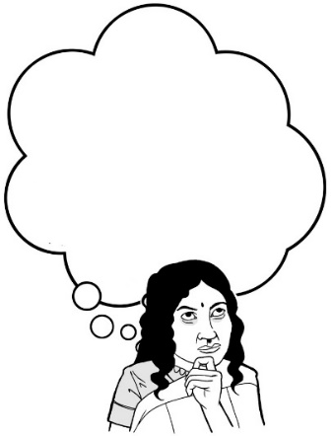
Question 11

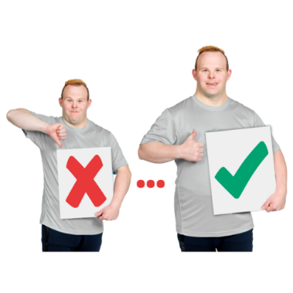
Do you think there are other ways of making decisions we should think about?

If yes what are these ways?

We are also thinking about if there are other things we could do to make decision making better.
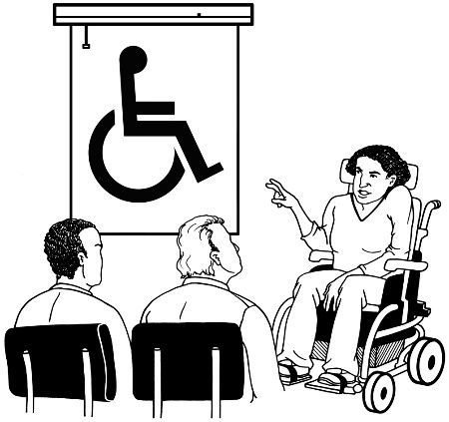
This could mean things like:
- giving training to support people
- having templates for documents about decision making.

Templates are example documents that you can use:

- to fill in your own information
- as a guide to show you what to write.

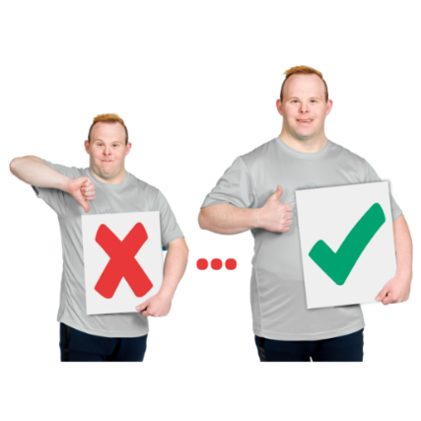
Question 12

What other things might make decision making better?

Safeguards and accountability

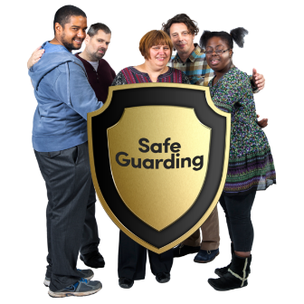
Safeguards are ways of making sure everyone involved in decision making is safe from harm.

Accountability means making sure people do what they are supposed to.

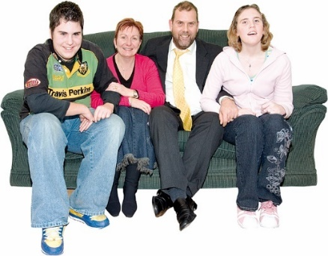
Lots of decision making is informal.

This means people decide among themselves how the decision making happens.

Lots of the time informal decision making works well.

However sometimes things can go wrong with informal decision making.

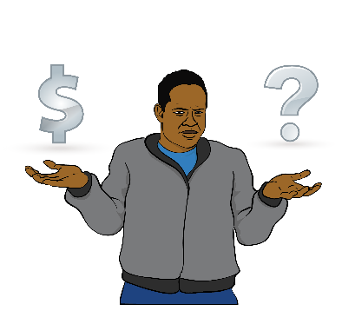
For example someone with a learning disability may have a parent decide how they spend their money even if they want to make more decisions about their money.

Question 13
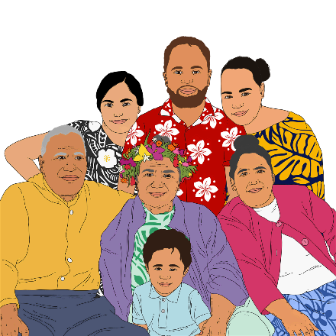
Do you think there need to be ways of making sure there are safeguards / accountability when someone has an informal supporter?

If yes what should they be?

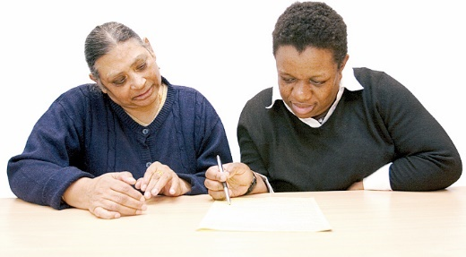
Enduring powers of attorney are when you choose someone to make decisions if you stop being able to.
There are already some safeguards / ways of accountability set up for enduring powers of attorney.

We have heard they may not work well.

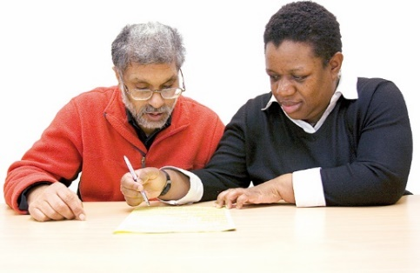
Question 14

Do you think there need to be different safeguards / accountability when someone uses an enduring power of attorney?

If yes what should they be?
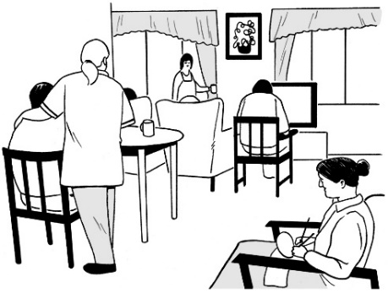

In some care homes people cannot choose to leave by themselves.

Question 15
Do you think there need to be safeguards / accountability when someone moves into a care home?

If yes what should they be?

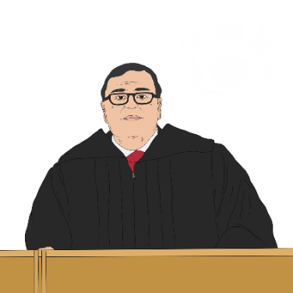
Sometimes the court decides who will make decisions for a person about their:

- health

- personal life.

The person who will make the decisions is called a welfare guardian.

There are already some safeguards / kinds of accountability set up for when a welfare guardian is used.

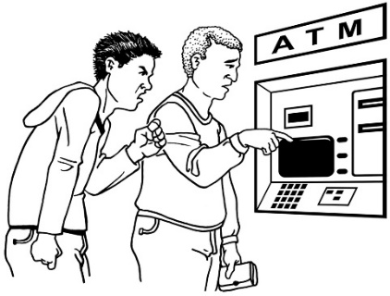
We have heard they may not always work well.

For example they may not work well when a welfare guardian makes decisions that cause harm.

Question 16

Do you think there need to be different safeguards / kinds of accountability when someone has a welfare guardian?

If yes what should they be?

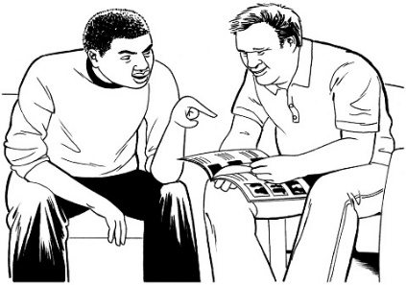
It is important that people who support others to make decisions are safe.

We have heard there is not always enough support for these people.

Question 17

Do you think there need to be safeguards / accountability to support people who support others to make decisions?

If yes what should they be?

Is there anything else you would
like to tell us?

There may be important things we have not talked about.

We want to hear about anything else you think is important.

We also want to know what it was like to make a submission.
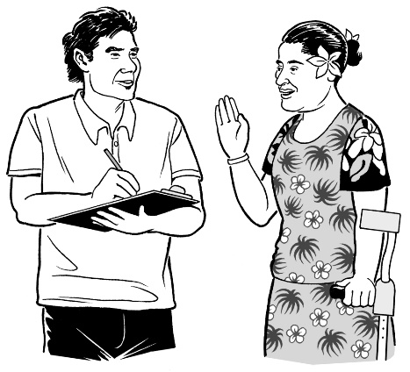

Question 18

Is there anything else you would like to tell us for this review?

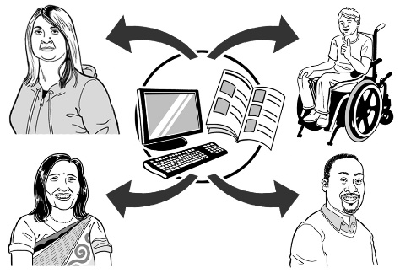
Question 19

How easily could you get information about:
- this review
- how to make a submission?

What could we do better?

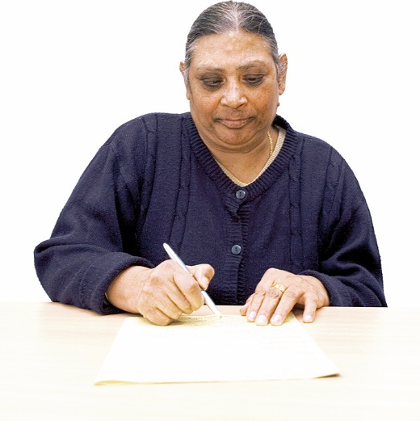
Question 20

How easy did you find making a submission?

What could we do to make it easier?

This information has been written by Te Aka Matua o te Ture | Law Commission.
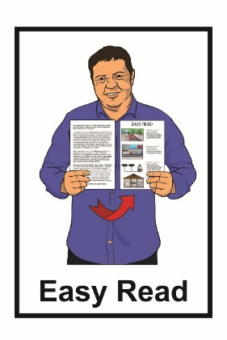
It has been translated into Easy Read by the Make It Easy service of People First New Zealand Inc. Ngā Tāngata Tuatahi.

The ideas in this document are not the ideas of People First New Zealand Inc. Ngā Tāngata Tuatahi.
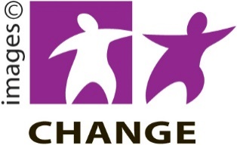
Make It Easy uses images from:

- Changepeople.org
- Photosymbols.com

- Sam Corliss
- Huriana Kopeke-Te Aho

All images used in this Easy Read document are subject to copyright rules and cannot be used without permission.

