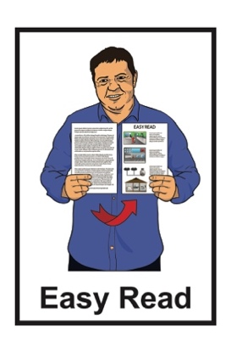

He arotake i te ture mō ngā huarahi whakatau a ngā pakeke

Review of adult decision-making capacity law

Key topic 1: Court-appointed representatives

Published: April 2024

What is in here

Page number:

What is this review? 3
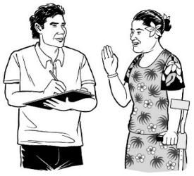

How to tell us what you think 9

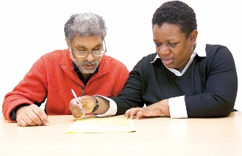
If you need support 12

What are court-appointed representatives? 14

Keeping court-appointed
representatives 18
Making someone a court-appointed representative 20

Page number:
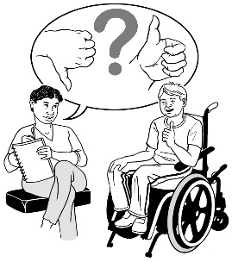

Changing what court-appointed representatives do 22

Checking how court-appointed representatives are doing. 29

Anything else you want to tell us. 32

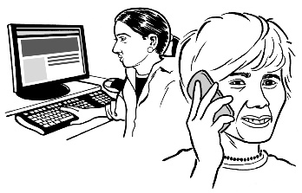
How to get in touch with us 33

What is this review?

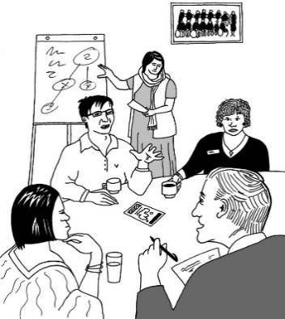
Te Aka Matua o te Ture – Law Commission is an organisation that:
- does reviews of the law
- uses what it finds out in the reviews to tell the Government how to make the law better.

A review is when we:
look carefully at a part of the law
talk to people who know a lot of things to do with that part of the law
ask people what they think
write a report about what we have found out.

In this Easy Read document when we say we / our this means the

Law Commission.

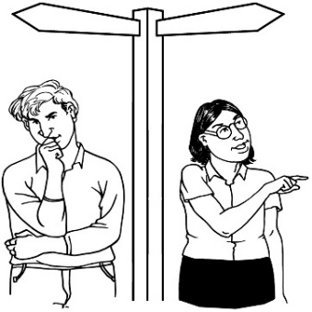
Some people find it hard to make decisions about their own lives.

In this document we will call people who find it hard to make decisions about their own lives people with affected decision making.

In this review we are looking at what the law should do when people have affected decision making.

As part of this review the Law Commission has written a document called the Second Issues Paper.

The Second Issues Paper:
explains problems with the law we have now
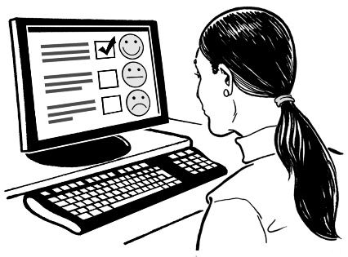
asks people to tell us how the law could be made better.

You can find the Second Issues Paper on our website at:

huarahi-whakatau.lawcom.govt.nz

The Second Issues Paper is not in Easy Read.

We have also written 4 documents called key topic documents.

These key topic documents:
talk about some of the most important things in the Second Issues Paper
ask some questions so you can tell us what you think.

This is the first of the key topic documents.

The key topic documents are in:
Easy Read
other alternate formats.

You can find the other key topic documents on our website at:

huarahi-whakatau.lawcom.govt.nz

There is an Easy Read document with more information about:
the review
the key topics
what we will do with your information if you tell us what you think.

The document is called:

Key topics information sheet

You can find it on our website at:

huarahi-whakatau.lawcom.govt.nz

You should read the Key topics information sheet first.

How to tell us what you think

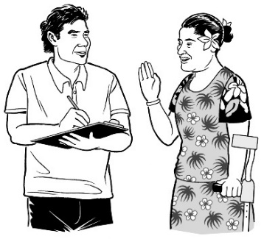
We want to hear what you think.

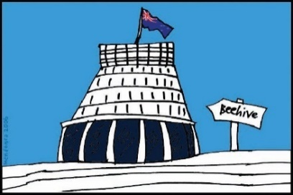
We will use what you tell us to make our report to the Government about what the law should be.

Telling us what you think is called making a submission.

There are questions about different things we will think about in the review in:
this document
the other key topics documents.

When you make your submission you can answer:
- all the questions
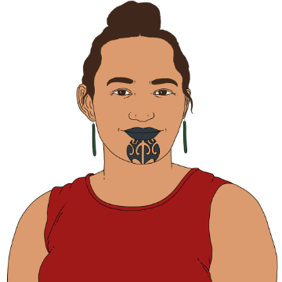
- just the questions you want to.

You can make a submission:
on your own
as part of a group.

You need to get your submission to us by:

5 pm Friday 21 June 2024.

You can make a submission by emailing us at:

huarahi.whakatau@lawcom.govt.nz
You can also post your submission to:

Review of Adult Decision Making Capacity Law

Law Commission

PO Box 2590

Wellington 6140

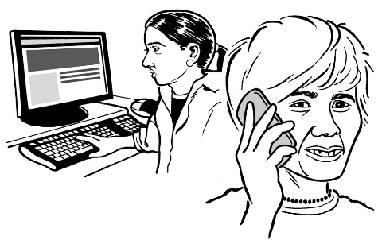
If you cannot make a submission in these ways please get in touch with us.

If you need support

Some people might find it makes them sad to:
think about the things in the review
make a submission.

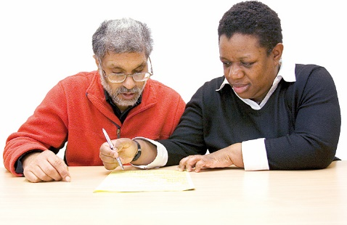
You can ask someone to support you to make a submission.

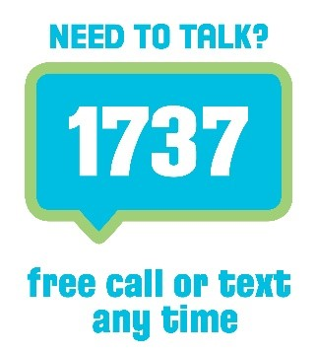
If you are upset you can also contact:

1737: Need to Talk

At 1737: Need to Talk you can talk to a counsellor by:
calling: 1737
texting: 1737

1737: Need to Talk is open all
day / night.

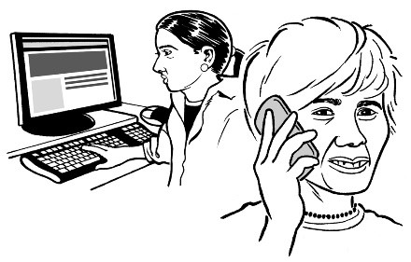
If the 1737 number does not work from your phone you can call this number:

0800 1737 1737

You can find out more about 1737: Need to Talk on this website:

www.1737.org.nz

What are court-appointed representatives?

Sometimes the court will say someone can make decisions for a person with affected decision making.

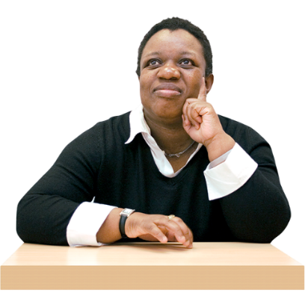
This person is called a
court-appointed representative.

In this document we will also call them the representative.

We will call the person with affected decision making the
represented person.

A law called the Protection of Personal and Property Rights Act 1988 says there can be different kinds of representatives.

In this document we will call the Protection of Personal and Property Rights Act 1988 the
PPPR Act.

The kinds of representatives in the PPPR act are:
welfare guardian
property guardian.

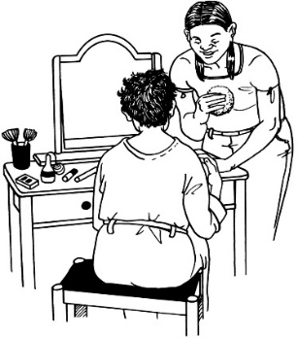
A welfare guardian is a representative who makes decisions about things like:
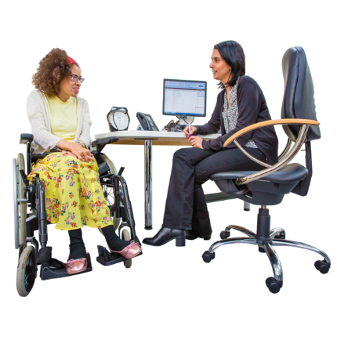
personal care
medical treatment
where the person with affected decision making lives.

A property guardian is a representative who makes decisions about things like:
money
a house owned by the person with affected decision making.

The court decides who the representatives will be.

Often the representatives are family members / friends of the person with affected decision making.

Keeping court-appointed representatives

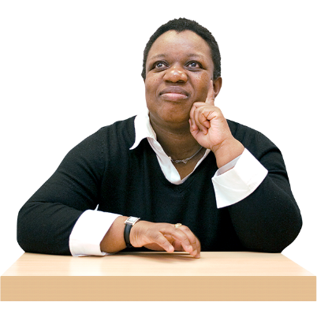
Some people think there should not be court-appointed representatives.

They think that:
people should always be able to make their own decisions
people should not be able to make decisions for someone else.

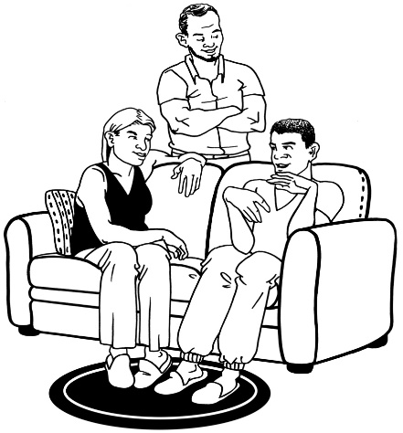
Other people think there are times when representatives are needed.

We think there should still be representatives in our law.

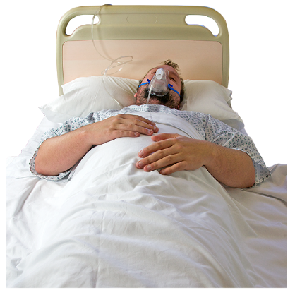
We think there will sometimes be times when a person needs someone else to make decisions for them.

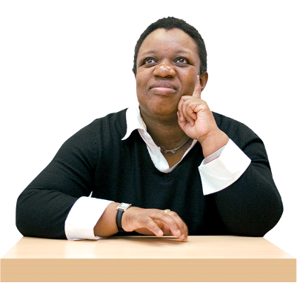
We also think there need to be changes to make the law clearer about:
when there should be a court-appointed representative
what representatives do.

Making someone a court-appointed representative

We are looking at when a representative might be needed.

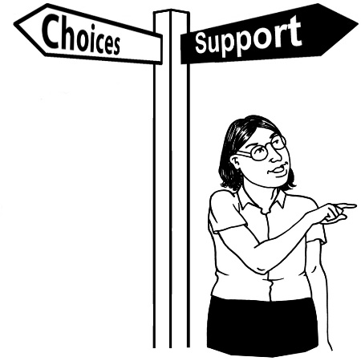
1 thing the court looks at when deciding if there should be a representative is if the person with affected decision making has capacity.

Having capacity means someone can make their own decisions.

We think the courts should think about other things as well.

For example they should think about if the person with affected decision making is likely to be harmed if they do not have a representative.

Question 1.1:

When might someone need a court-appointed representative?

Question 1.2:

What sorts of things should the court think about when they decide if someone needs a representative?

Changing what court-appointed representatives do

The law we have now says that when representatives make decisions they:
should support the represented person to be part of decisions as much as they can
must act in the best interests of the represented person.

Best interests means what is good for a person.

Representatives are also supposed to talk to the represented person to see what they think.

Representatives should also talk to the family of the represented person.
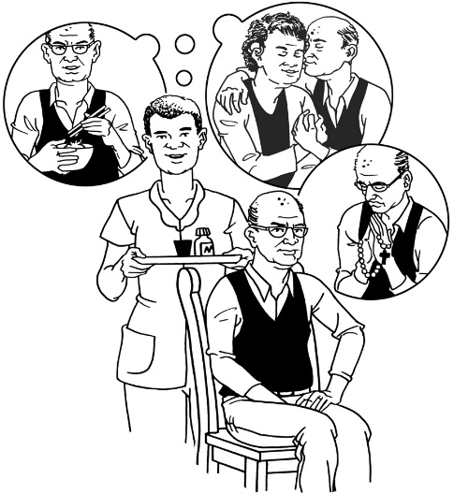

We think the law should change so what the representative does is much more about what the represented person wants.

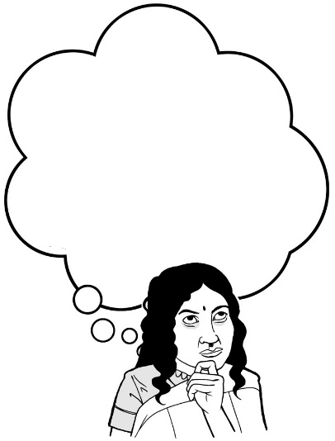
This is sometimes called making a decision based on will and preferences.

We want to know how a court-appointed representative should work out what the represented person wants.
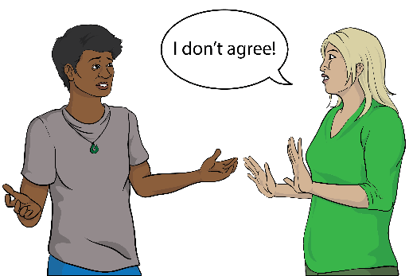
For example we think the representative should think about what the represented person says about something.

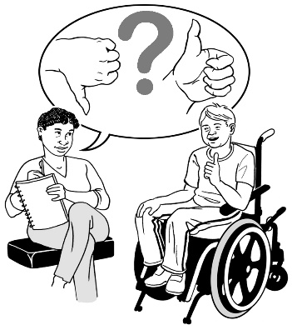
The representative might also think about things like:
what the represented person has said in the past
what things the represented person likes
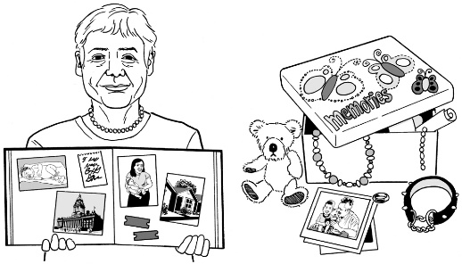
what is important to the represented person.

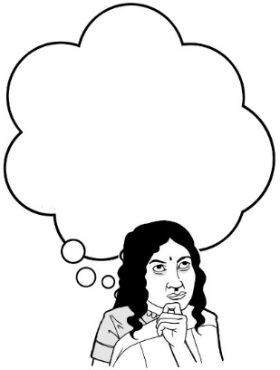
Question 1.3:

What should a representative think about when working out what a represented person wants?

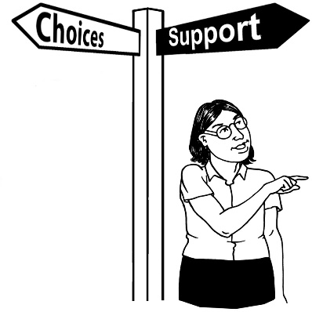
Sometimes it might not work to make a decision based just on what the represented person wants.

This might be because:
the represented person cannot say what they want
what they want might lead to them being harmed badly.

In these cases the representative might think about things like:
human rights
the wellbeing of the affected person.

Human rights are rights to make sure everyone:
is treated fairly
has what they need to live a good life.

Wellbeing is having a good life in lots of different ways like:
- feeling safe
- being able to learn
- making friends.

Question 1.4:

When might it not work to make a decision based only on what the represented person wants?

Question 1.5:

How should representatives make decisions when it does not work to make a decision based only on what the donor wants?

It is important for the representative to have a clear way of doing things when making decisions for a represented person.

This could mean:
- thinking about what support the represented person might need to be part of the decision
- talking to:
- the represented person
- other people important to them.
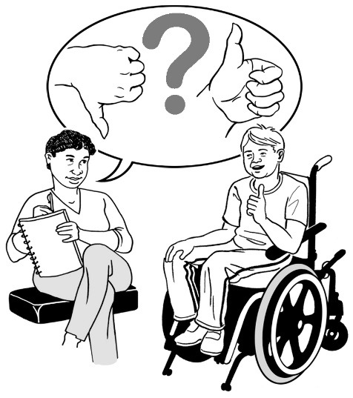
It could also mean seeing if the represented person said things earlier about:
- how they want decisions to be made
- who they want to be talked to.

Checking how court-appointed representatives are doing

It is important to check to make sure:
the representative is doing the job well
having a representative is still working for the represented person.

The court checks how things are going every few years.

This is called a court review.
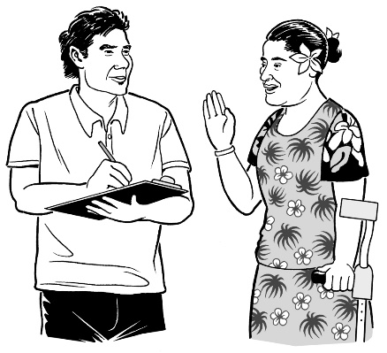

People should also be able to say something if representatives are not doing things the way they should be.
The main way this happens now is by people going to court.

It is important there is a balance so that:
people are checking what representatives do
but
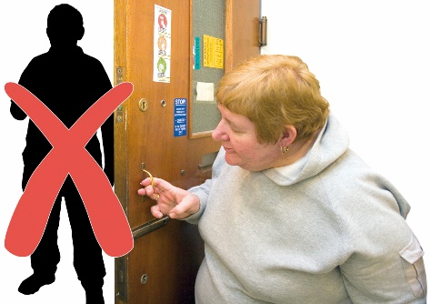
the court is not getting too involved in the lives of represented people.

Court reviews can:
cost a lot of money
be stressful
take a lot of time.

There might be better ways of checking how things are going.

Question 1.6:

How should representatives be checked to make sure things are working well?

Anything else you want to tell us

You can tell us anything else you want to say about these topics.

Question 1.7:

What else do you want to tell us about court-appointed representatives?

How to get in touch with us

You can get in touch with us by:
email at:
huarahi.whakatau@lawcom.govt.nz
phone on:
0800 832 526

If you find it hard to use the phone the New Zealand Relay service is for people who are:
Deaf / hard of hearing
deafblind
speech impaired / find it hard to talk.

You can find out more about the New Zealand Relay service at:

www.nzrelay.co.nz

This information has been written by Te Aka Matua o te Ture – Law Commission.

It has been translated into Easy Read by the Make it Easy Kia Māmā Mai service of People First New Zealand Ngā Tāngata Tuatahi.
The ideas in this document are not the ideas of People First New Zealand Ngā Tāngata Tuatahi.

Make it Easy uses images from:

- Changepeople.org

            - Photosymbols.com

- SGC Image Works
- Huriana Kopeke-Te Aho
- T. Wood.
All images used in this Easy Read document are subject to copyright rules and cannot be used without permission.

