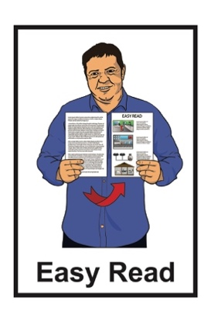

He arotake i te ture mō ngā huarahi whakatau a ngā pakeke

Review of adult decision-making capacity law
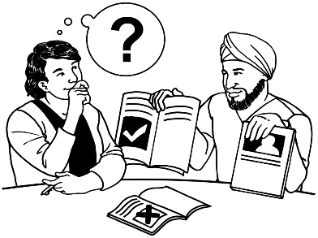

Key topic 2: Decision-making support

Published: April 2024

What is in here

Page number:

What is this review? 3
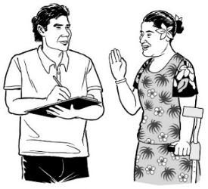

How to tell us what you think 9

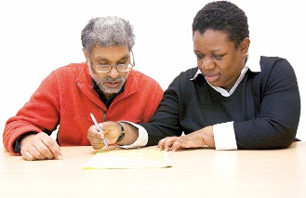
If you need support 12

What is decision-making support? 14

What stops people getting
decision-making support? 19
How could a new law make
decision-making support work
better? 22

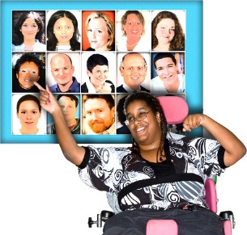
Page number:

Making support stronger in the
legal arrangements we have now 24

Formal supporter arrangements. 27

Anything else you want to tell us. 31

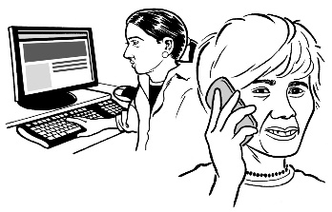
How to get in touch with us 32

What is this review?

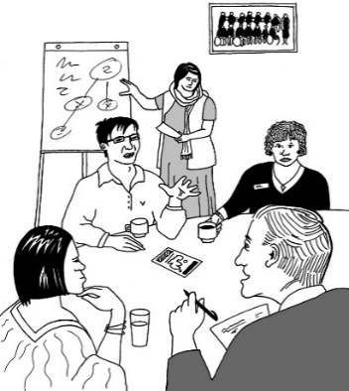
Te Aka Matua o te Ture – Law Commission is an organisation that:
- does reviews of the law
- uses what it finds out in the reviews to tell the Government how to make the law better.

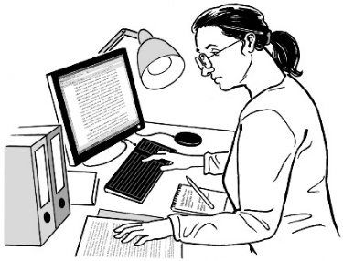
A review is when we:
look carefully at a part of the law
talk to people who know a lot of things to do with that part of the law
ask people what they think
write a report about what we have found out.

In this Easy Read document when we say we / our this means the

Law Commission.

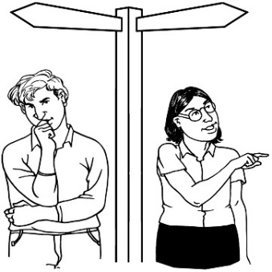
Some people find it hard to make decisions about their own lives.

In this document we will call people who find it hard to make decisions about their own lives people with affected decision making.

In this review we are looking at what the law should do when people have affected decision making.

As part of this review the Law Commission has written a document called the Second Issues Paper.

The Second Issues Paper:
explains problems with the law we have now
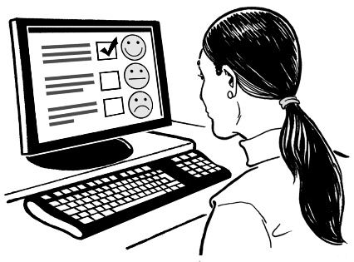
asks people to tell us how the law could be made better.

You can find the Second Issues Paper on our website at:

huarahi-whakatau.lawcom.govt.nz
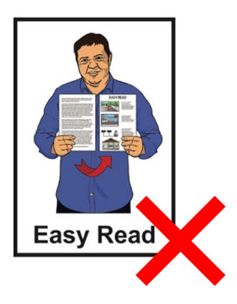

The Second Issues Paper is not in Easy Read.

We have also written 4 documents called key topic documents.

These key topic documents:
talk about some of the most important things in the Second Issues Paper
ask some questions so you can tell us what you think.

This is the second of the key topic documents.

The key topic documents are in:
Easy Read
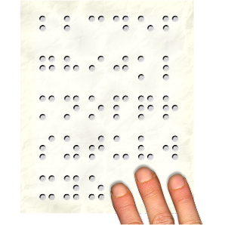
other alternate formats.

You can find the other key topic documents on our website at:

huarahi-whakatau.lawcom.govt.nz

There is an Easy Read document with more information about:
the review
the key topics
what we will do with your information if you tell us what you think.

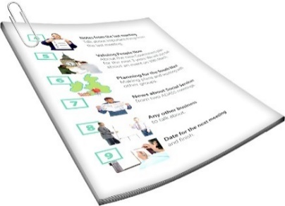
The document is called:

Key topics information sheet

You can find it on our website at:

huarahi-whakatau.lawcom.govt.nz

You should read the Key topics information sheet first.

How to tell us what you think

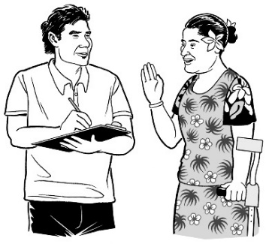
We want to hear what you think.

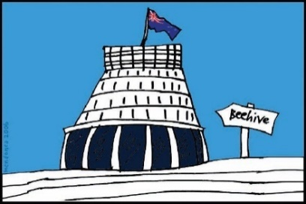
We will use what you tell us in our report to the Government about what the law should be.

Telling us what you think is called making a submission.

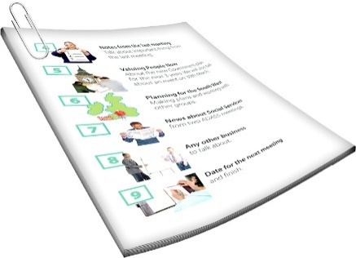
There are questions about different things we will think about in the review in:
this document
the other key topics documents.

When you make your submission you can answer:
- all the questions
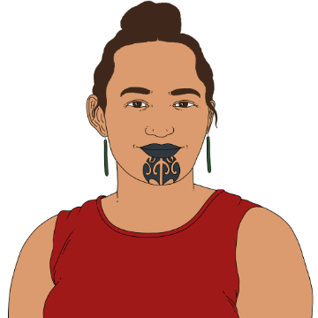
- just the questions you want to.

You can make a submission:
on your own
as part of a group.

You need to get your submission to us by:

5 pm Friday 21 June 2024.

You can make a submission by emailing us at:

huarahi.whakatau@lawcom.govt.nz
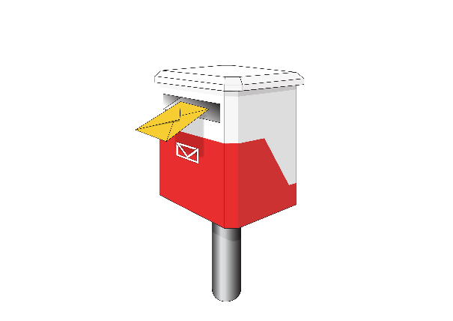
You can also post your submission to:

Review of Adult Decision Making Capacity Law

Law Commission

PO Box 2590

Wellington 6140

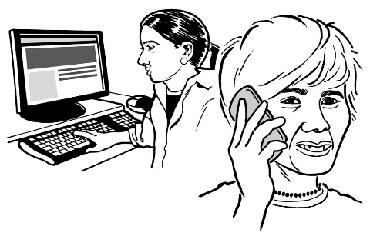
If you cannot make a submission in these ways please get in touch with us.

If you need support

Some people might find it makes them sad to:
think about the things in the review
make a submission.

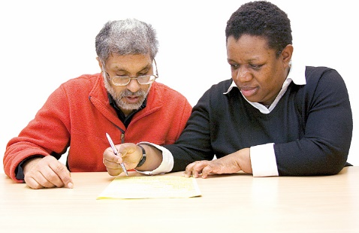
You can ask someone to support you to make a submission.

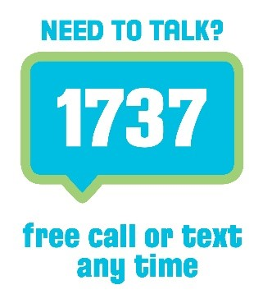
If you are upset you can also contact:

1737: Need to Talk

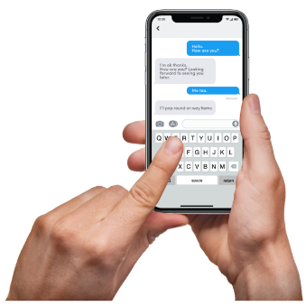
At 1737: Need to Talk you can talk to a counsellor by:
calling: 1737
texting: 1737

1737: Need to Talk is open all
day / night.

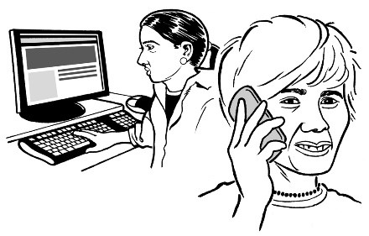
If the 1737 number does not work from your phone you can call this number:

0800 1737 1737

You can find out more about 1737: Need to Talk on this website:

www.1737.org.nz

What is decision-making support?

We all make some decisions with the support of other people.

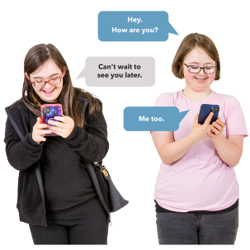
Sometimes we:
ask for advice from
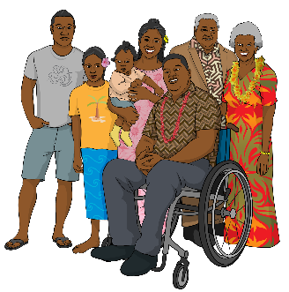
- friends
- family
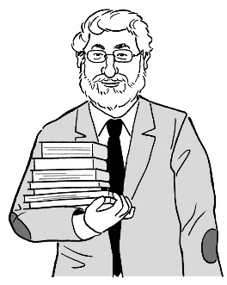
- experts who are people who know a lot about something
need someone to:
- explain information to us
- talk things over with.

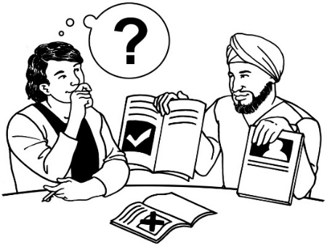
These are all kinds of
decision-making support.

For people with affected decision making it can be very important to have decision-making support.

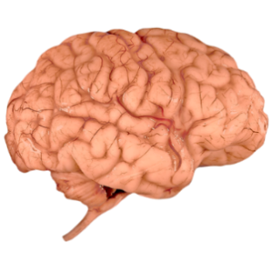
Affected decision making can be caused by many things such as:
- brain injuries
- dementia
- learning disabilities
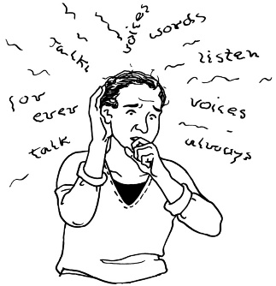
- experiences of mental distress
- other conditions or disabilities that affect how people make decisions.

Dementia is a health condition where people can find it hard to:
remember things
understand things.

There are many kinds of decision-making support.

One kind of decision-making support is having another person to do things like:
work out what decision needs to be made
explain information about the decision
talk through the pros and cons.

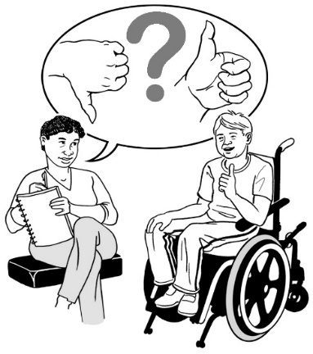
Pros means the good things about deciding something.

Cons means the bad things about deciding something.

Other kinds of decision-making support include:
having more time to make a decision
having a quiet place to think about a decision
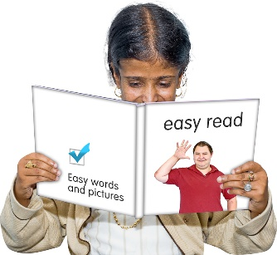
having information in accessible formats like
- Easy Read
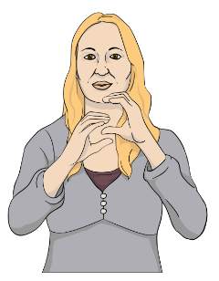
- New Zealand Sign Language.

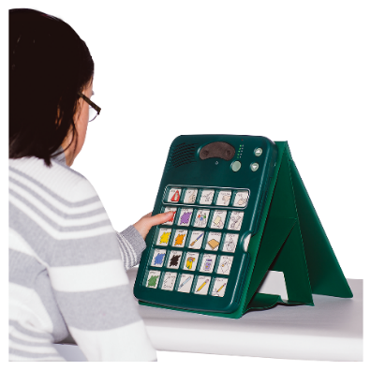
Another kind of decision-making support is being able to get communication assistance like:
- talking mats
- speech generating devices.
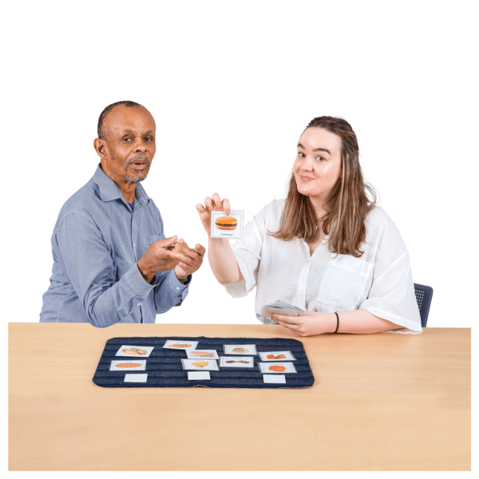

Talking mats are a way to support people to tell other people things using a mat with cards on it.
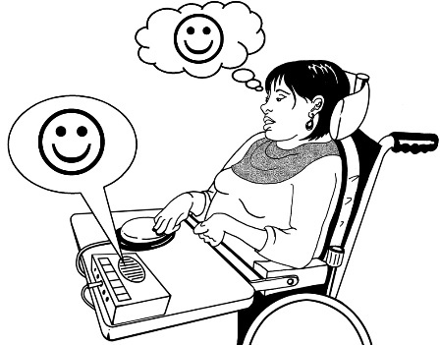

Speech generating devices say words the person using them chooses out loud.

What stops people getting decision-making support?

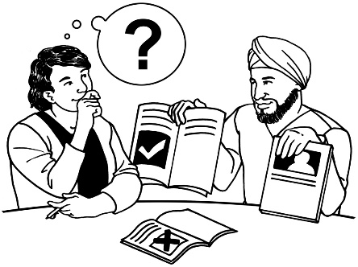
People have told us that sometimes people with affected decision making do not get the decision-making support that they need.

Sometimes people / organisations like doctors or banks do not work well with supporters.

They may not understand that the person with affected decision making can still make their own decisions if they have support.
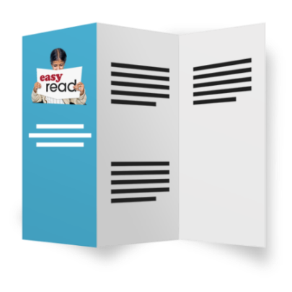

They may not give supporters the information they need.
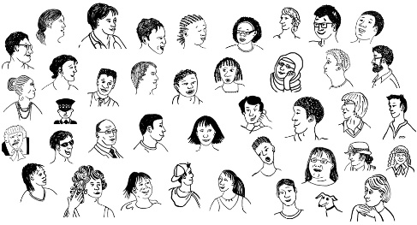
Some other problems we have heard about are:
sometimes there is no-one who can be a supporter
supporters may not know how to do support well
other kinds of support like accessible information are not always available
some supporters take advantage of people with affected decision making.

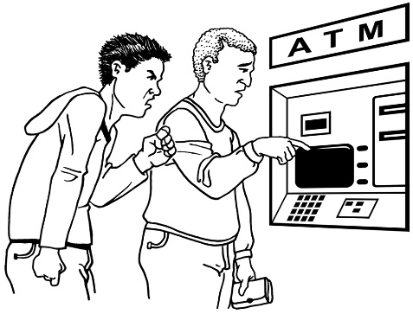
Take advantage means to trick someone or treat them unfairly to get something like:
money
the person to do what you want.

We want to know what stops people getting good decision-making support.

Question 2.1

What things stop people getting good decision-making support?

How could a new law make decision-making support work better?

One of the main laws to do with affected decision making is called the Protection of Personal and Property Rights Act 1988.

In this document we will call the Protection of Personal and Property Rights Act 1988 the
PPPR Act.

We think there should be a new law instead of the PPPR Act.

The new law should be more about what the person with affected decision-making wants.

We are thinking about the ways the new law could deal with the things that stop people getting good decision-making support.

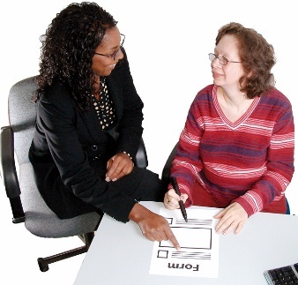
The 2 main ways we are thinking about are:
making support stronger in the legal arrangements we have now
formal supporter arrangements.

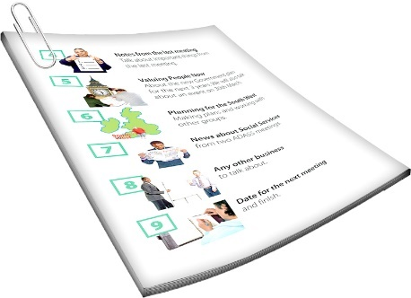
We will explain both of these in the next parts of this document.

Making support stronger in the legal arrangements we have now

Some of the legal arrangements we have now are:
Enduring Powers of Attorney
court-appointed representatives.

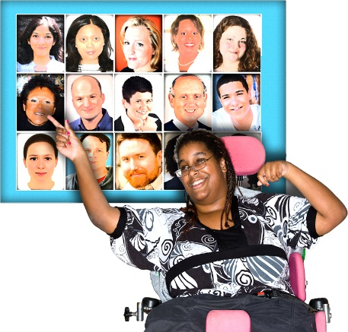
An Enduring Power of Attorney is when a person chooses someone to make decisions for them if they have affected decision making in the future.

Enduring Powers of Attorney are also called EPOAs.

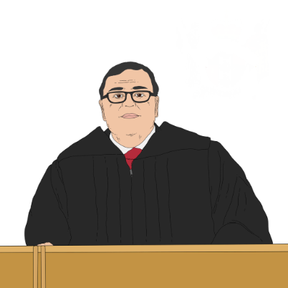
A court-appointed representative is someone the court says can make decisions for someone else.

There is more information on support in existing legal arrangements in these parts of the Second Issues Paper:
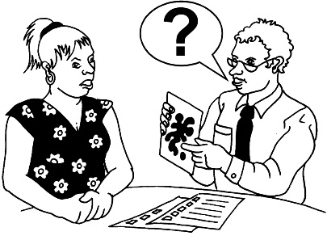
Chapter 7 talks about support when seeing if people can make their own decisions
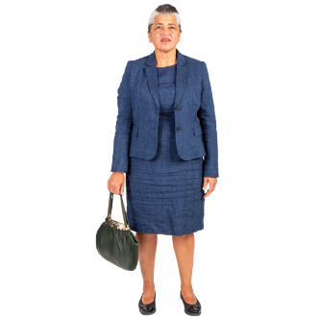
Chapter 10 talks about support in court-appointed representative arrangements
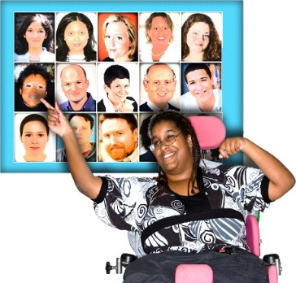
Chapter 13 talks about support in Enduring Power of Attorney arrangements
Chapter 17 talks about people being supported to be involved in court decisions.
You can find the Second Issues Paper on our website at:

huarahi-whakatau.lawcom.govt.nz

The Second Issues Paper is not in Easy Read.

We think support could be a bigger part of existing decision-making arrangements.

Formal supporter arrangements

At the moment there are no real rules about people being supporters.

Some countries have a new legal arrangement called a formal decision-making support arrangement.

This means:
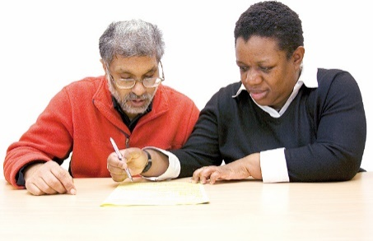
people sign a legal agreement with their supporter
the supporter assists the person they support to make decisions
there are rules about what a supporter needs to do.

We are thinking about if there should be formal decision-making support agreements in New Zealand.

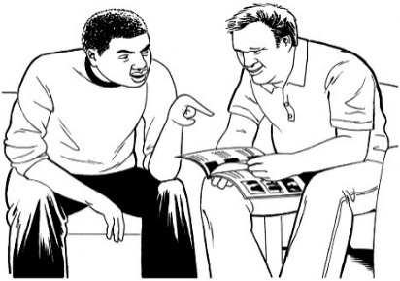
Formal decision-making support agreements might make it easier for people to get support.

It might mean places like banks or healthcare work better with supporters.

We also think formal decision making support arrangements might make things harder in some cases.

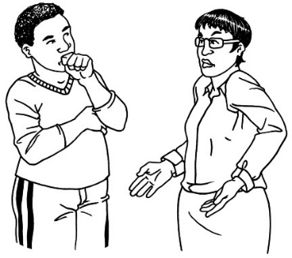
For example places like banks and healthcare may only want to deal with formal supporters.

This might make things harder for people who use other kinds of support.

Formal decision making support arrangements might mean people have to be part of a legal agreement even if they do not want to.

Being part of the legal agreement may cost money.

Having the law say what supporters need to do might mean people do not want to be supporters.

Question 2.2:
What do you think of these 2 things we have said might improve decision making support:
making support stronger in the legal arrangements we have now
formal decision making support arrangements?

Anything else you want to tell us

You can tell us anything else you want to say about these topics.

Question 2.3:

What else do you want to tell us about how decision-making support could be made better?

How to get in touch with us

You can get in touch with us by:
email at:
huarahi.whakatau@lawcom.govt.nz
phone on:
0800 832 526

If you find it hard to use the phone the New Zealand Relay service is for people who are:
Deaf / hard of hearing
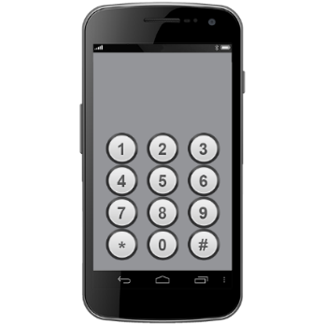
deafblind
speech impaired / find it hard to talk.

You can find out more about the New Zealand Relay service at:

www.nzrelay.co.nz

This information was written by Te Aka Matua o te Ture – Law Commission.

It has been translated into Easy Read by the Make it Easy Kia Māmā Mai service of People First New Zealand Ngā Tāngata Tuatahi.
The ideas in this document are not the ideas of People First New Zealand Ngā Tāngata Tuatahi.

Make it Easy uses images from:

- Changepeople.org

            - Photosymbols.com

- SGC Image Works
- Huriana Kopeke-Te Aho
- T. Wood.
All images used in this Easy Read document are subject to copyright rules and cannot be used without permission.

