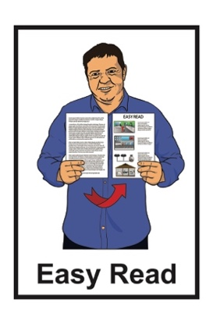

He arotake i te ture mō ngā huarahi whakatau a ngā pakeke

Review of adult decision-making capacity law

Key topic 3: Enduring Powers of Attorney

Published: April 2024

What you will find in here

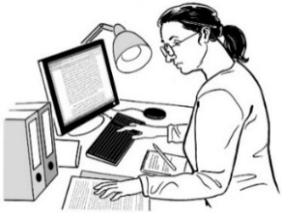
Page number:

What is this review? 3
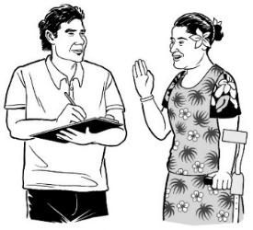

How to tell us what you think 9

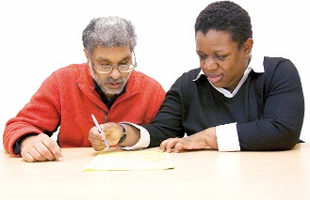
If you need support 12

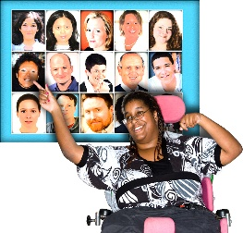
What is an Enduring Power
of Attorney? 14

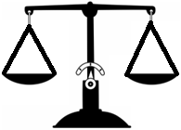
Why do we need EPOAs? 18
Setting up an EPOA 20

Page number:
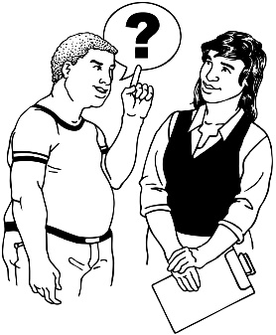

Protections when an EPOA
is set up 25

Changing what attorneys do 29

Anything else you want to tell us. 36

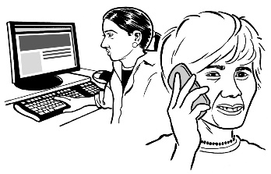
How to get in touch with us 37

What is this review?

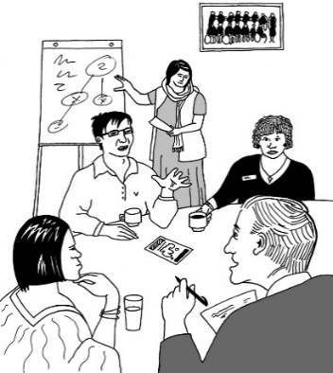
Te Aka Matua o te Ture – Law Commission is an organisation that:
- does reviews of the law
- uses what it finds out in the reviews to tell the Government how to make the law better.
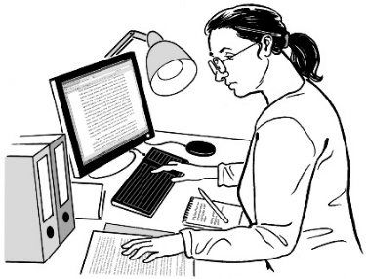

A review is when we:
look carefully at a part of the law
talk to people who know a lot of things to do with that part of the law
ask people what they think
write a report about what we have found out.
In this Easy Read document when we say we / our this means the

Law Commission.

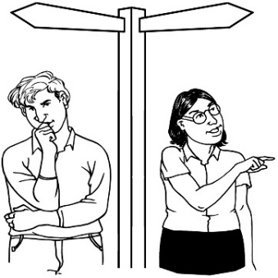
Some people find it hard to make decisions about their own lives.

In this document we will call people who find it hard to make decisions about their own lives people with affected decision making.

In this review we are looking at what the law should do when people have affected decision making.

As part of this review the Law Commission has written a document called the Second Issues Paper.

The Second Issues Paper:
explains problems with the law we have now
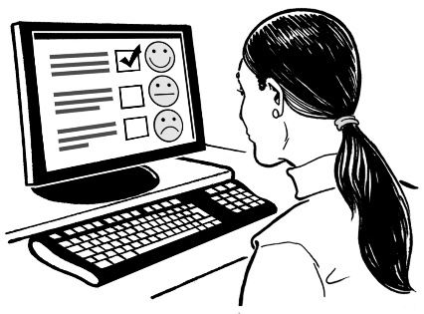
asks people to tell us how the law could be made better.

You can find the Second Issues Paper on our website at:

huarahi-whakatau.lawcom.govt.nz
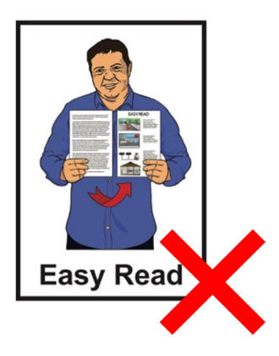

The Second Issues Paper is not in Easy Read.

We have also written 4 documents called key topic documents.

These key topic documents:
talk about some of the most important things in the Second Issues Paper
ask some questions so you can tell us what you think.

This is the third of the key topic documents.

The key topic documents are in:
Easy Read
other alternate formats.

You can find the other key topic documents on our website at:

huarahi-whakatau.lawcom.govt.nz

There is an Easy Read document with more information about:
the review
the key topics
what we will do with your information if you tell us what you think.

The document is called:

Key topics information sheet

You can find it on our website at:

huarahi-whakatau.lawcom.govt.nz/

You should read the Key topics information sheet first.

How to tell us what you think

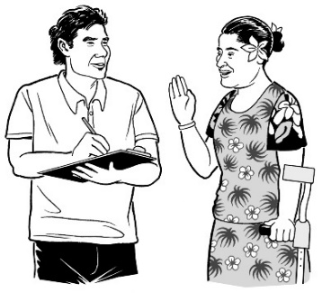
We want to hear what you think.

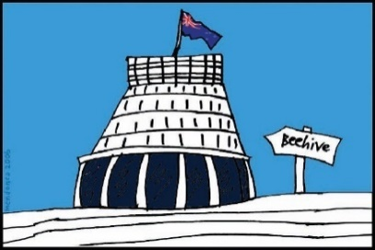
We will use what you tell us in our report to the Government about what the law should be.

Telling us what you think is called making a submission.

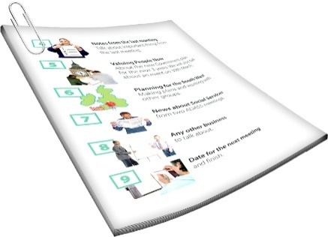
We have some questions that we would like you to think about when you make your submission.

You can find these questions in:
this document
the other key topics documents.

When you make your submission you can answer:
- all the questions
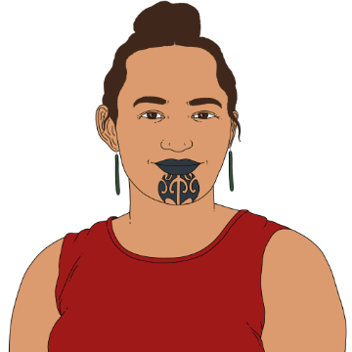
- just the questions you want to.

You can make a submission:
on your own
as part of a group.

You need to get your submission to us by:

5 pm Friday 21 June 2024.
You can make a submission by emailing us at:

huarahi.whakatau@lawcom.govt.nz
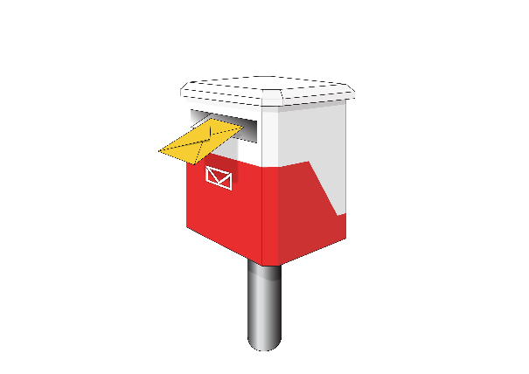
You can also post your submission to:

Review of Adult Decision Making Capacity Law

Law Commission

PO Box 2590

Wellington 6140

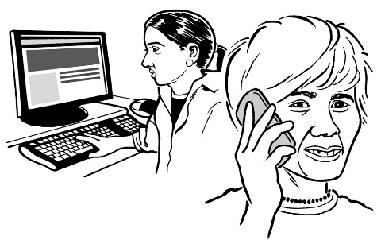
If you cannot make a submission in these ways please get in touch with us.

If you need support

Some people might find it makes them sad to:
think about the things in the review
make a submission.

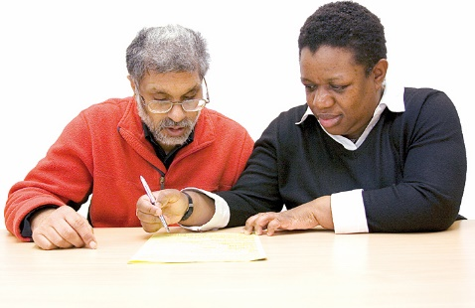
You can ask someone to support you to make a submission.

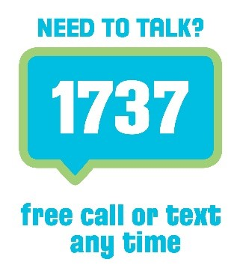
If you are upset you can also contact:

1737: Need to Talk

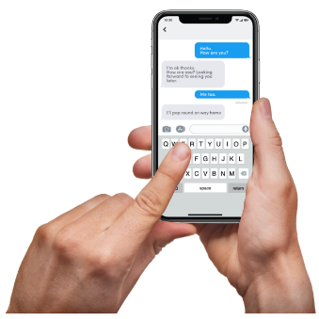
At 1737: Need to Talk you can talk to a counsellor by:
calling: 1737
texting: 1737

1737: Need to Talk is open all
day / night.

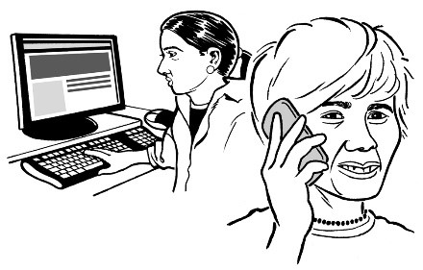
If the 1737 number does not work from your phone you can call this number:

0800 1737 1737

You can find out more about 1737: Need to Talk on this website:

www.1737.org.nz

What is an Enduring Power of Attorney?

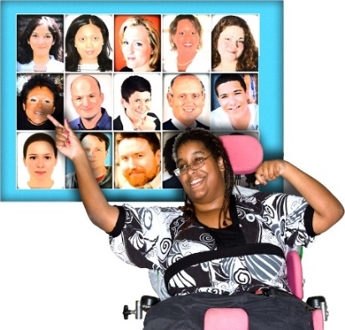
An Enduring Power of Attorney is when a person chooses someone to make decisions for them if they have affected decision making in the future.

The future is a time that has not happened yet.

The person who chooses someone to make decisions for them is called the donor.

The person who makes decisions for them is called the attorney.

Enduring Powers of Attorney are also called EPOAs.
Affected decision making can be caused by many things such as:
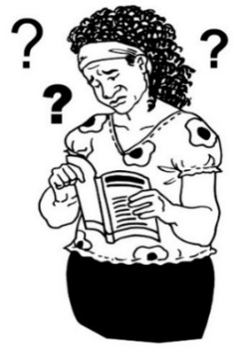
brain injuries
dementia
learning disabilities
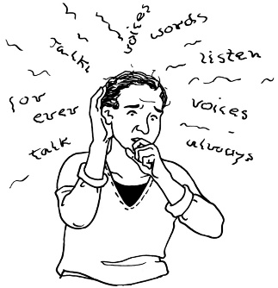
experiences of mental distress
other conditions or disabilities that affect how people make decisions.

Dementia is a health condition where people can find it hard to:
remember things
understand things.

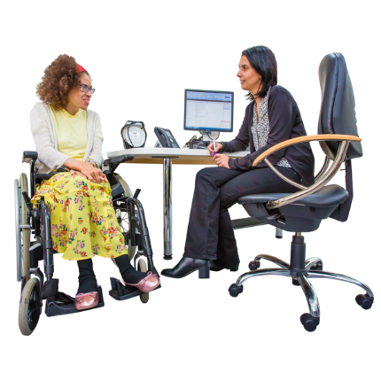
There are 2 kinds of EPOAs:
- personal care and welfare EPOA
- property EPOA.

A personal care and welfare EPOA is for decisions about things like:
some medical treatment
where the donor lives.

A property EPOA is for decisions about things like:
money
a house owned by the donor.

People usually make both kinds of EPOA.

The person they choose to be their attorney is usually a:
family member
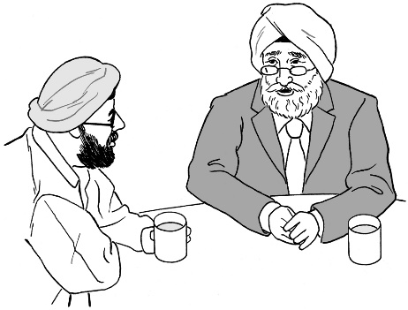
close friend.

Why do we need EPOAs?

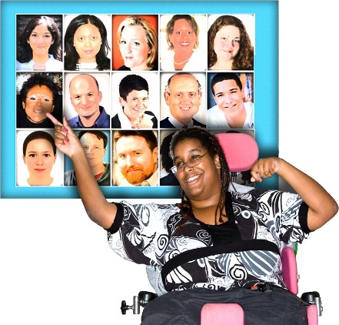
The law about EPOAs is meant to do 2 things:
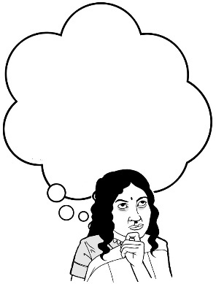
- allow people to have other people make decisions for them without going to court
- protect people by making sure:
- the donor understands what their decision to have an EPOA means
- the attorney is using their powers in the right way.

These 2 things need to be balanced.

Balanced means having an even mix of both things – not too much of 1 or the other.

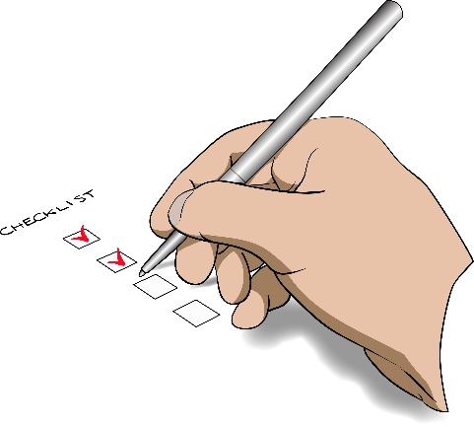
We want to know how to find the best balance so we have both:
good ways of doing things that keep people safe
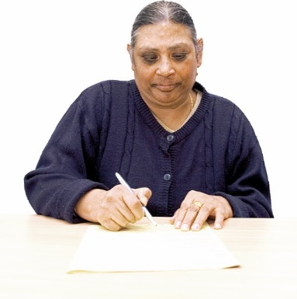
EPOAs that:
- are not too complicated / hard to do
- do not cost a lot of money.

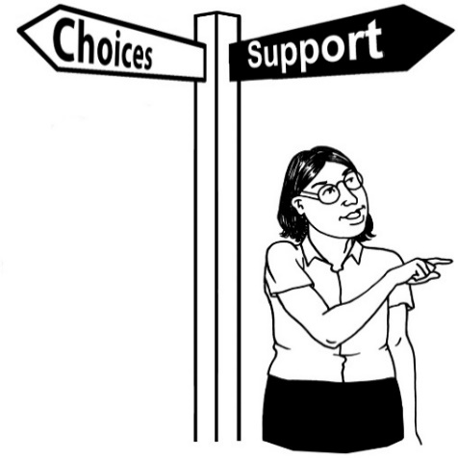
EPOAs are important because they mean people can make their own choices about:

what they want to happen in the future

how they want important decisions to be made.

Setting up an EPOA

Making an EPOA involves:
filling out forms
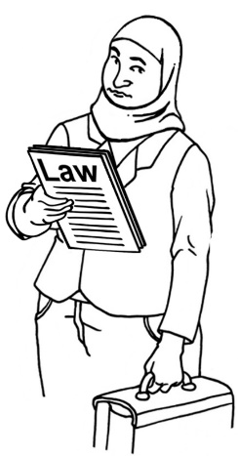
signing them in front of a witness who is usually a lawyer.

A witness is someone who can confirm you signed the form.

The witness must agree that:
they think the donor understands the EPOA
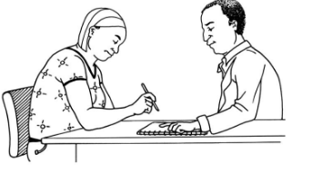
they do not think anyone is pushing the donor to sign the EPOA.
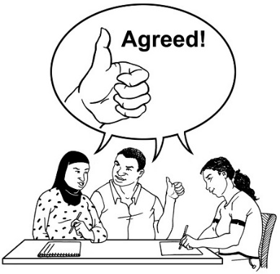
The witness must also agree they have no reason to think the donor is mentally incapable.

Mentally incapable means someone the law says cannot make their own decisions because of how their brain works.

Someone may be mentally incapable because of something like dementia.

Many people find setting up an EPOA:
complicated / hard to do
costs a lot of money.

Some of the reasons for this are:
the forms are:
- long
- hard to understand
paying for a lawyer to be the witness costs a lot of money.

Another reason for this is the witness has to agree to a lot of different things.

It is not clear if it needs to be a lawyer who agrees to all of them.

Some ways we could change things are:
changing some of the things that the witness needs to agree to
letting other kinds of people witness an EPOA not just lawyers
changing the forms so they are:
- in plain language
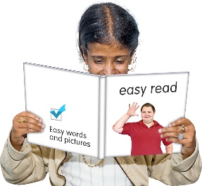
- easier to use
- in accessible formats like Easy Read or Braille.
allowing remote witnessing.

Remote witnessing means the witness:
can do their job on the internet
does not need to be in the same room as the donor.

Question 3.1

How could the law make it easier to set up an EPOA while still making sure people are protected?

Protections when an EPOA is set up

The law has some ways of protecting donors once they have set up an EPOA.

Here are some of the ways the law protects donors.

The attorney is usually only allowed to make decisions when the donor can no longer make their own decisions.

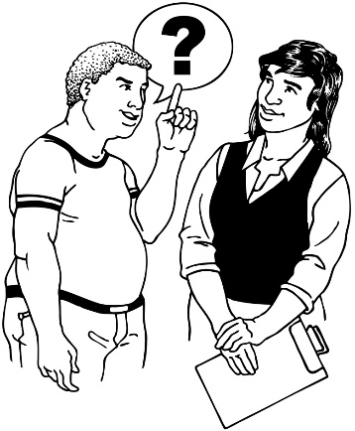
The EPOA can say that some people can ask for information from the attorney about what the attorney is doing.

Property attorneys must keep records of money.

Records are things that are written down.

The court can also:
check the decisions attorneys make
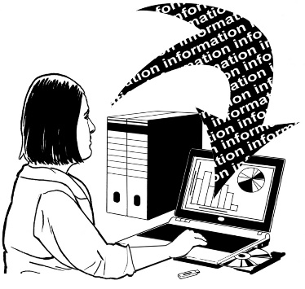
tell attorneys they have to give the court information
stop people being attorneys if they are not doing things right.
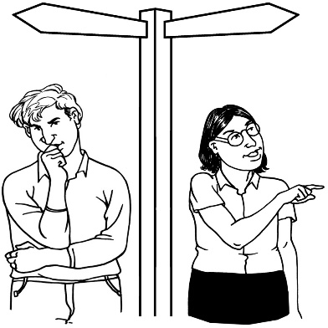

These protections may not do enough to check what attorneys are doing.

People do not always understand when an attorney can start making decisions for the donor.

The rules about the records attorneys have to keep may not be the best for making sure they are doing the right thing.

Some people think they have to do too much to keep records.

It is not clear how often records are:
kept
checked.

There is no-one checking how well the attorney is doing unless this is put in the EPOA.
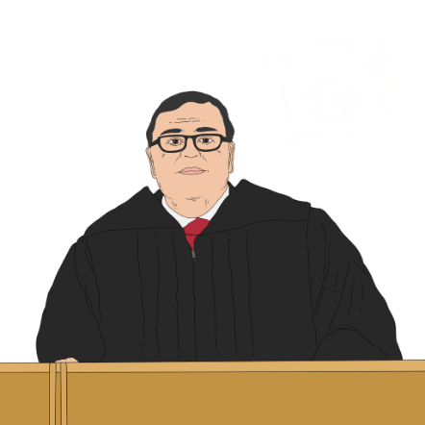
The only way to say attorneys should do things differently is through the court.

This can:
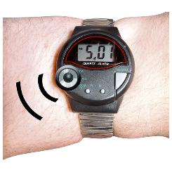
cost a lot of money
be slow
be stressful.

Not enough checking how things are going makes it easier for attorneys to do things wrong.

If attorneys have too many rules then people may not want to be attorneys.

Question 3.2:

What protections should there be once an EPOA is set up?

Changing what attorneys do

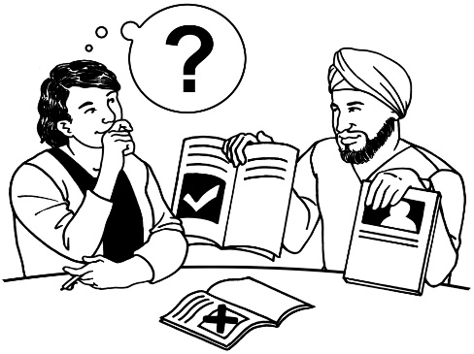
The law we have now says that when attorneys make decisions they:
should support the donor to be part of decisions as much as they can
must act in the best interests of the donor.

Best interests means what is good for a person.

Attorneys are also supposed to talk to the donor to see what they think.

Attorneys should also talk to the family of the donor.
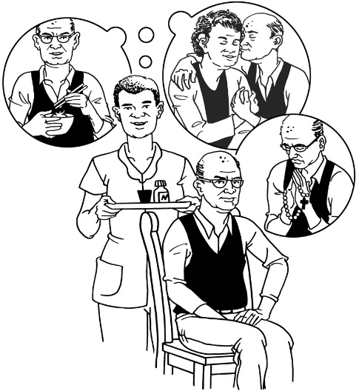

We think the law should change so what the attorney does is much more about what the donor wants.

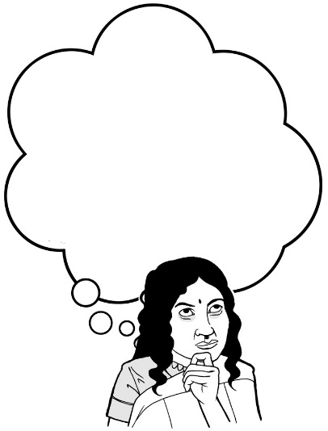
This is sometimes called making a decision based on will and preferences.

We want to know how an attorney should work out what the donor wants.

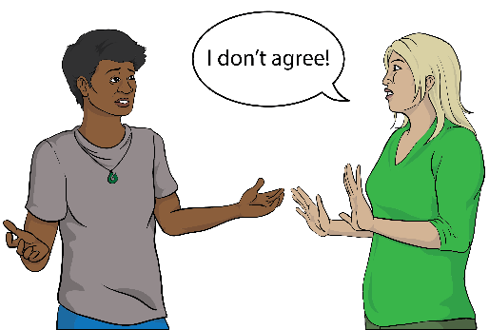
For example we think the attorney should think about what the donor says about something.

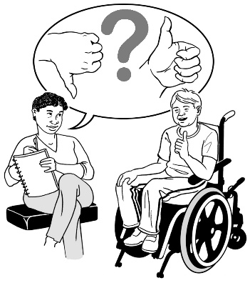
The attorney might also think about things like:
what the donor has said in the past
what things the donor likes
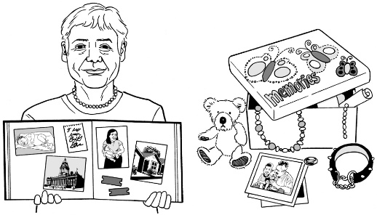
what is important to the donor.

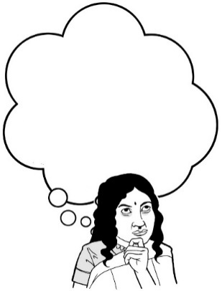
Question 3.3:

What should an attorney consider when working out what a donor wants?

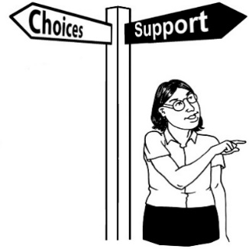
Sometimes it might not work to make a decision based just on what the donor wants.

This might be because:
the donor cannot say what they want
what they want might lead to them being harmed badly.
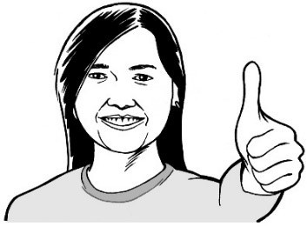

In these cases the attorney might think about things like:
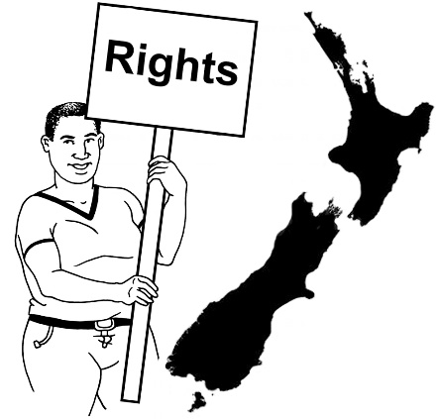
human rights
the wellbeing of the donor.

Human rights are rights to make sure everyone:
is treated fairly
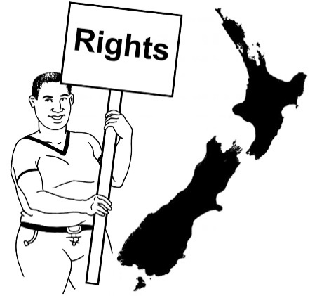
has what they need to live a good life.

Wellbeing is having a good life in lots of different ways like:
- feeling safe
- being able to learn
- making friends.

Question 3.4:

When might it not work to make a decision based only on what the donor wants?

Question 3.5:

How should attorneys make decisions when it does not work to make a decision based only on what the donor wants ?

It is important for the attorney to have a clear way of doing things when making decisions for a donor.

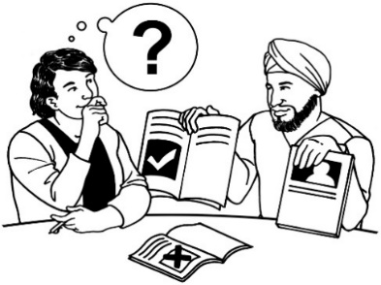
This could mean:
- thinking about what support the donor might need to be part of the decision
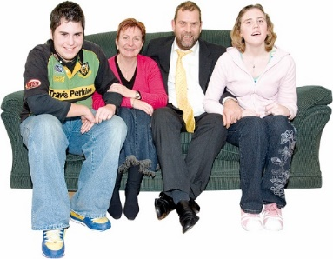
- talking to the donor / other important people to them.

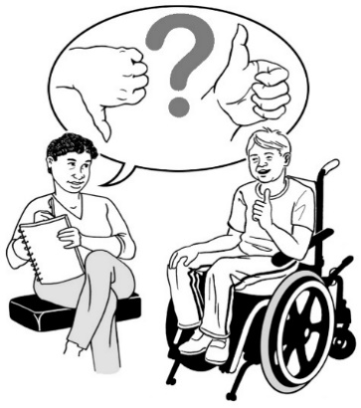
It could also mean seeing if the donor said things earlier about:
- how they want decisions to be made
- who they want to be talked to.

Question 3.6:

What steps should an attorney take when making a decision for a donor?

Anything else you want to tell us

You can also tell us anything else you want to say about these topics.

Question 3.7:

What else do you want to tell us about Enduring Powers of Attorney?

How to get in touch with us

You can get in touch with us by:
email at:
huarahi.whakatau@lawcom.govt.nz
phone on: 0800 832 526

If you find it hard to use the phone the New Zealand Relay service is for people who are:
Deaf / hard of hearing
deafblind
speech impaired / find it hard to talk.

You can find out more about the New Zealand Relay service at:

www.nzrelay.co.nz

This information was written by Te Aka Matua o te Ture - Law Commission.

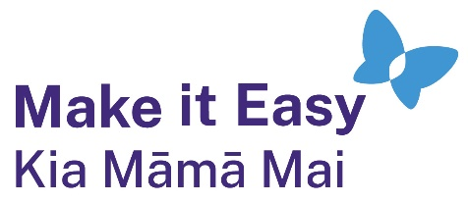
It has been translated into Easy Read by the Make it Easy Kia Māmā Mai service of People First New Zealand Ngā Tāngata Tuatahi.
The ideas in this document are not the ideas of People First New Zealand Ngā Tāngata Tuatahi.
Make it Easy uses images from:

- Changepeople.org

            - Photosymbols.com

- SGC Image Works
- Huriana Kopeke-Te Aho
- T. Wood.
All images used in this Easy Read document are subject to copyright rules and cannot be used without permission.

