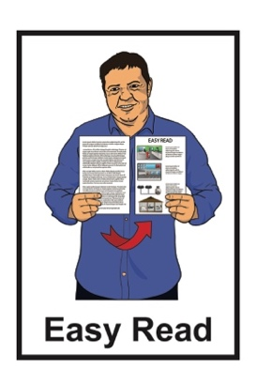

He arotake i te ture mō ngā huarahi whakatau a ngā pakeke

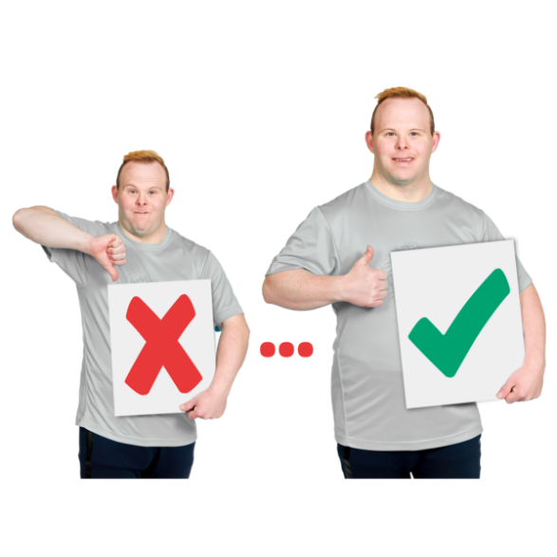
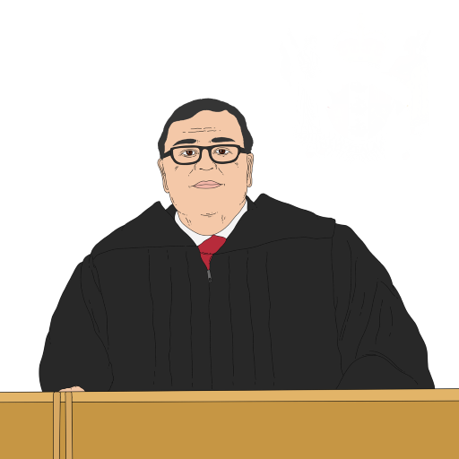
Review of adult decision-making capacity law

Key topic 4:
Practical improvements and court processes

Published: April 2024

What you will find in here

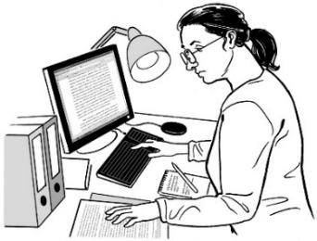
Page number:

What is this review? 3
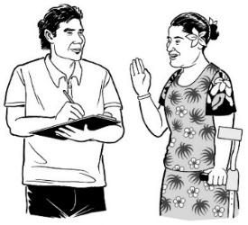

How to tell us what you think 9

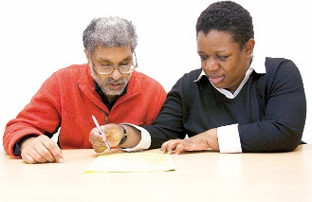
If you need support 12
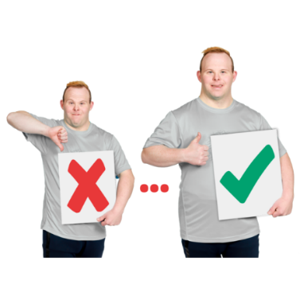

What are practical improvements? 14

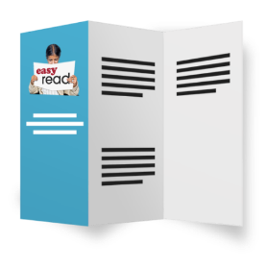
Access to information and
guidance 17
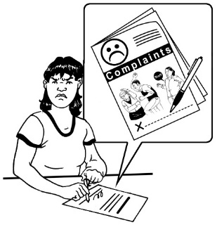
Making complaints 22

Page number:

Other ways to make things better 27

Making how courts work easier
for people 32

Anything else you want to tell us. 37

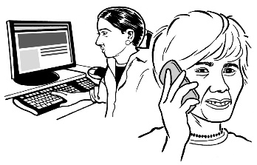
How to get in touch with us 38

What is this review?

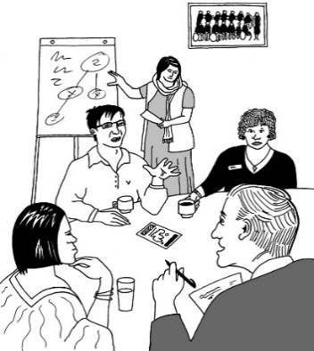
Te Aka Matua o te Ture – Law Commission is an organisation that:
- does reviews of the law
- uses what it finds out in the reviews to tell the Government how to make the law better.

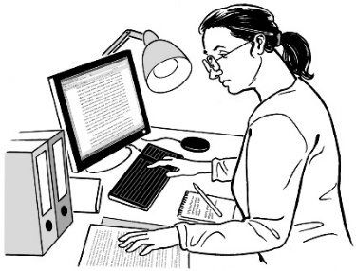
A review is when we:
look carefully at a part of the law
talk to people who know a lot of things to do with that part of the law
ask people what they think
write a report about what we have found out.

In this Easy Read document when we say we / our this means the

Law Commission.

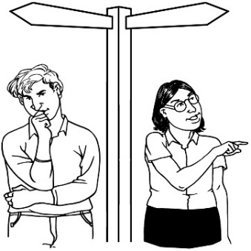
Some people find it hard to make decisions about their own lives.

In this document we will call people who find it hard to make decisions about their own lives people with affected decision making.

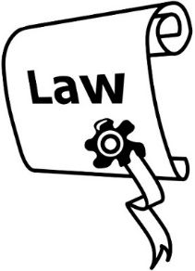
In this review we are looking at what the law should do when people have affected decision making.

As part of this review the Law Commission has written a document called the Second Issues Paper.

The Second Issues Paper:
explains problems with the law we have now
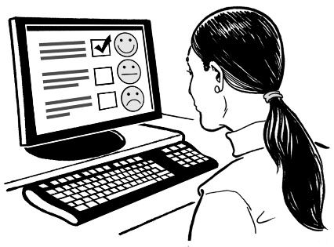
asks people to tell us how the law could be made better.

You can find the Second Issues Paper on our website at:

huarahi-whakatau.lawcom.govt.nz
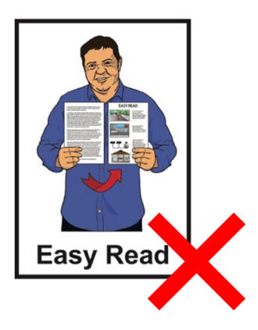

The Second Issues Paper is not in Easy Read.

We have also written 4 documents called key topic documents.

These key topic documents:
talk about some of the most important things in the Second Issues Paper
ask some questions so you can tell us what you think.

This is the fourth of the key topic documents.

The key topic documents are in:
Easy Read
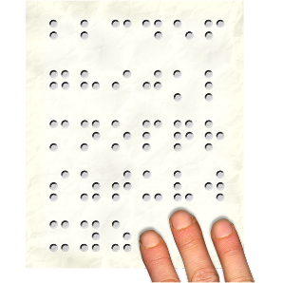
other alternate formats.

You can find the other key topic documents on our website at:

huarahi-whakatau.lawcom.govt.nz

There is an Easy Read document with more information about:
the review
the key topics
what we will do with your information if you tell us what you think.

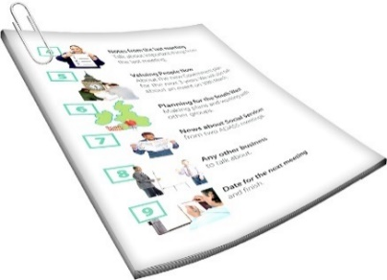
The document is called:

Key topics information sheet

You can find it on our website at:

huarahi-whakatau.lawcom.govt.nz/

You should read the Key topics information sheet first.

How to tell us what you think

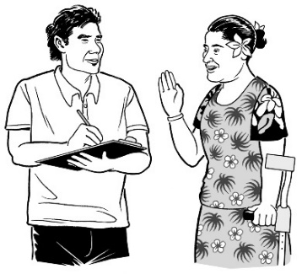
We want to hear what you think.

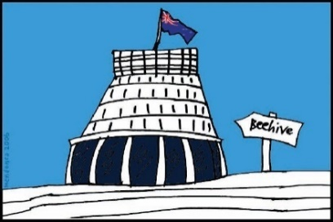
We will use what you tell us in our report to the Government about what the law should be.

Telling us what you think is called making a submission.

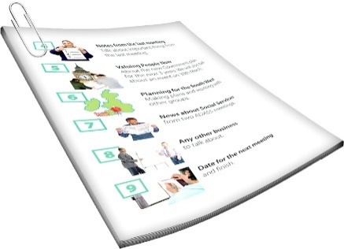
We have some questions that we would like you to think about when you make your submission.

You can find these questions in:
this document
the other key topics documents.

When you make your submission you can answer:
- all the questions
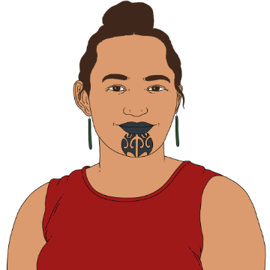
- just the questions you want to.

You can make a submission:
on your own
as part of a group.

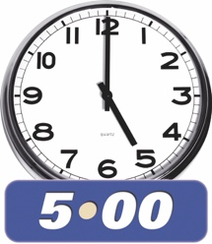
You need to get your submission to us by:

5 pm Friday 21 June 2024.
You can make a submission by emailing us at:

huarahi.whakatau@lawcom.govt.nz
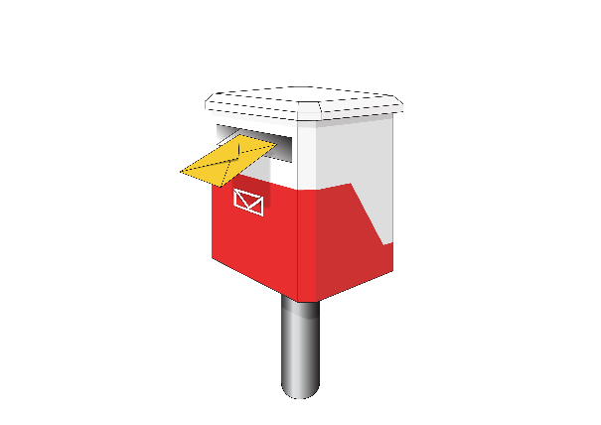
You can also post your submission to:

Review of Adult Decision Making Capacity Law

Law Commission

PO Box 2590

Wellington 6140

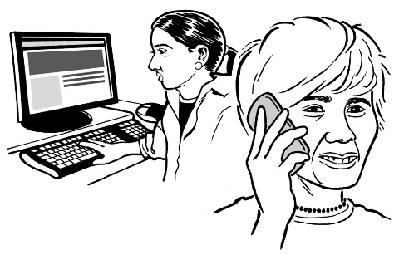
If you cannot make a submission in these ways please get in touch with us.

If you need support

Some people might find it makes them sad to:
think about the things in the review
make a submission.

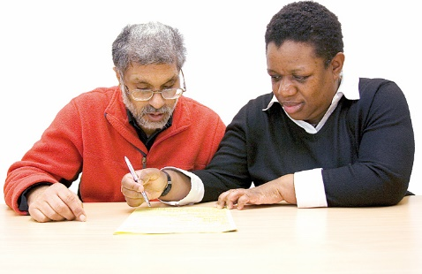
You can ask someone to support you to make a submission.

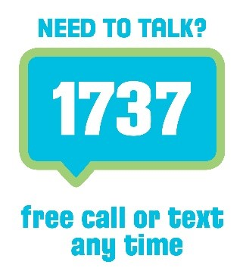
If you are upset you can also contact:

1737: Need to Talk

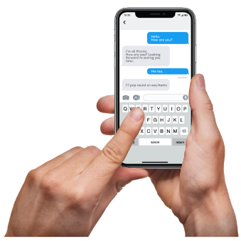
At 1737: Need to Talk you can talk to a counsellor by:
calling: 1737
texting: 1737

1737: Need to Talk is open all
day / night.

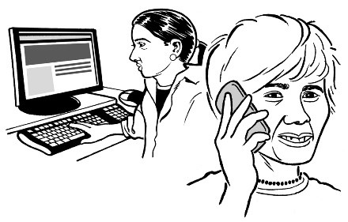
If the 1737 number does not work from your phone you can call this number:

0800 1737 1737

You can find out more about 1737: Need to Talk on this website:

www.1737.org.nz

What are practical improvements?
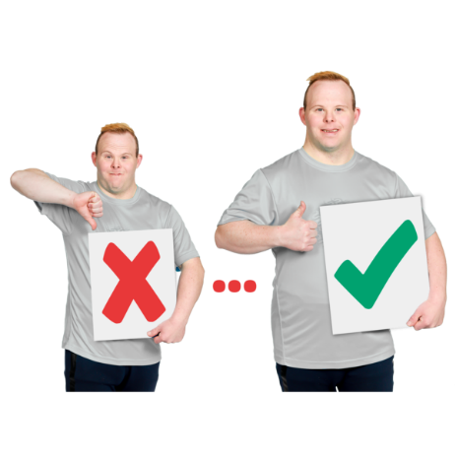

Practical improvements are things that can be done to make things better.

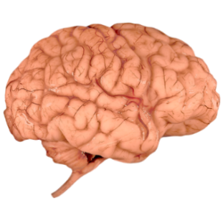
Affected decision making can be caused by many things such as:
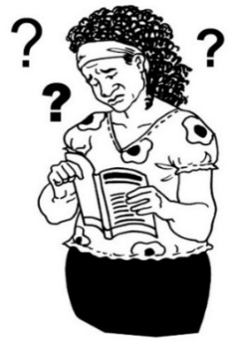
brain injuries
dementia
learning disabilities
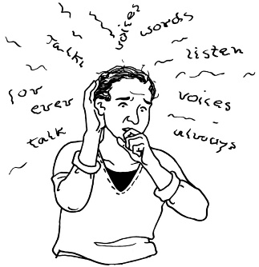
experiences of mental distress
other conditions or disabilities that affect how people make decisions.

Dementia is a health condition where people can find it hard to:
remember things
understand things.

People have told us about lots of things that can be hard when:
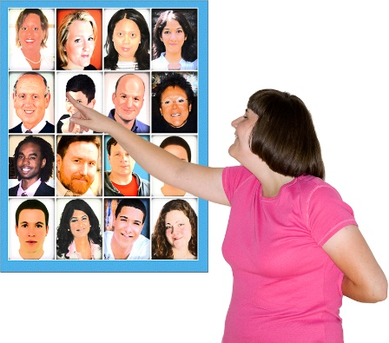
someone has affected decision making
and
a decision making arrangement might be needed.

Decision making arrangements are legal ways of deciding how decisions are made when someone has affected decision making.

Examples of decision making arrangements are:
Enduring Powers of Attorney
court-appointed representatives.

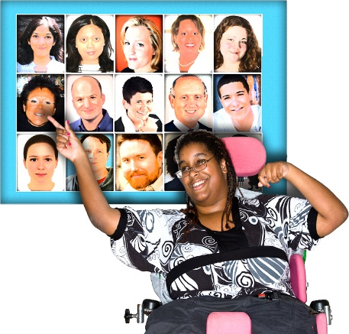
An Enduring Power of Attorney is when a person chooses someone to make decisions for them if they have affected decision making in the future.

Enduring Powers of Attorney are also called EPOAs.

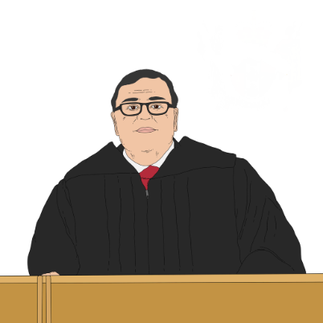
A court-appointed representative is someone the court says can make decisions for someone else.

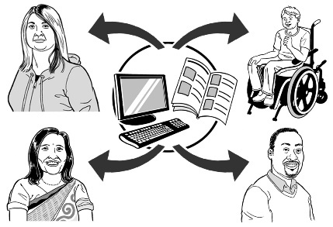
We are looking mostly at issues in 3 groups:
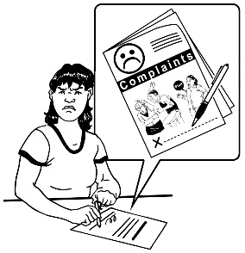
access to information / guidance
making complaints
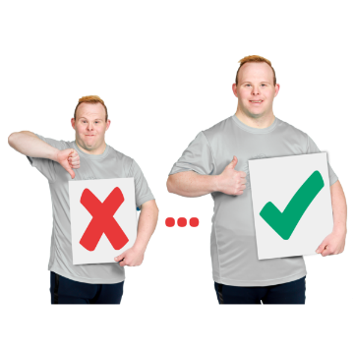
other ways to make things work better.

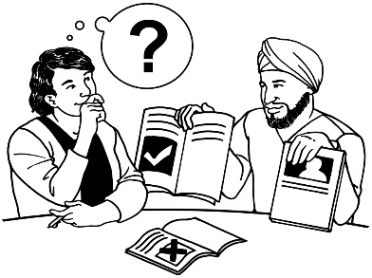
Guidance is when someone supports you to decide what to do.

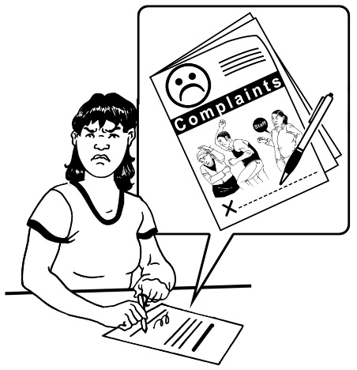
Making a complaint is when you tell someone that:
you are unhappy about something
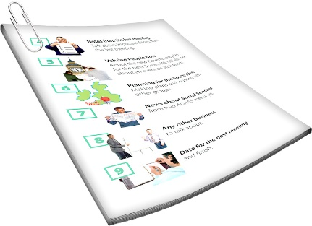
you want something to be done about that thing to make things better.
We will talk more about all of these groups of issues in this document.

Access to information and guidance

Good information and guidance can be useful for:
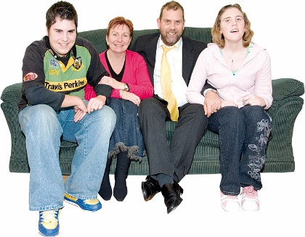
- adults who have affected decision making
- people who support them.

Examples of information and guidance are:
- information for adults with affected decision making about their rights
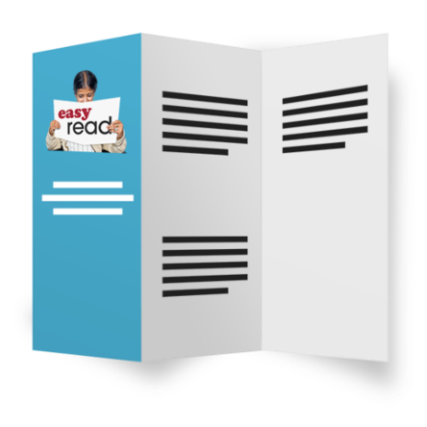
- information about the different kinds of decision making arrangements
- guidance about the law / courts.

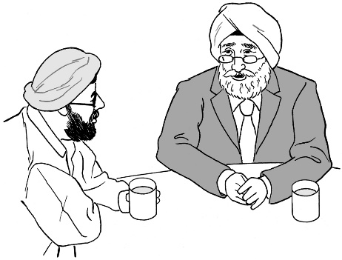
Another example of information and guidance is guidance for people who make decisions about:
- how to do things
- how to give good support on decision making.

In our review people told us that information and guidance need to be made better.

Some people do not know about ways of setting up decision making arrangements.

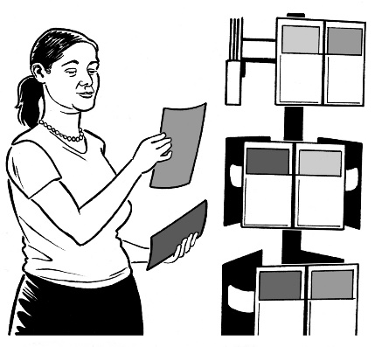
Some people think there is not enough information on how to set up decision making arrangements.

The information and guidance we have can be:
hard to understand
not accessible.

People who work with adults with affected decision making do not always feel they know how to give them good support.

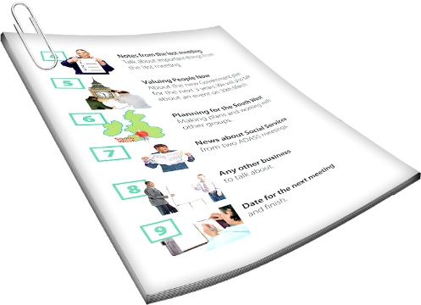
Question 4.1

What information and guidance would be useful?

Making complaints

Sometimes decision making arrangements do not go how they should.

People have told us there is not always an easy way to do something about it.

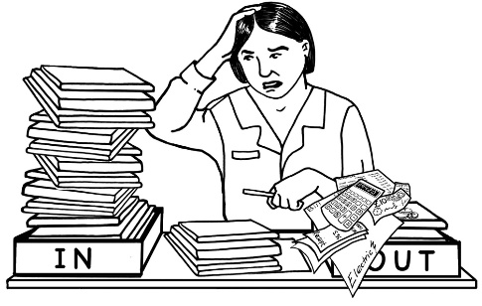
This might be if a person does not think a representative or attorney is doing their job well.

It also might be if friends / family members do not agree on the best way to support the person with affected decision making.

The main way to deal with this now is to go to court.

Going to court can:
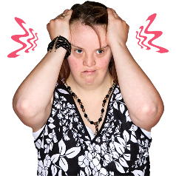
cost a lot of money
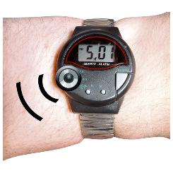
be stressful
take a long time.

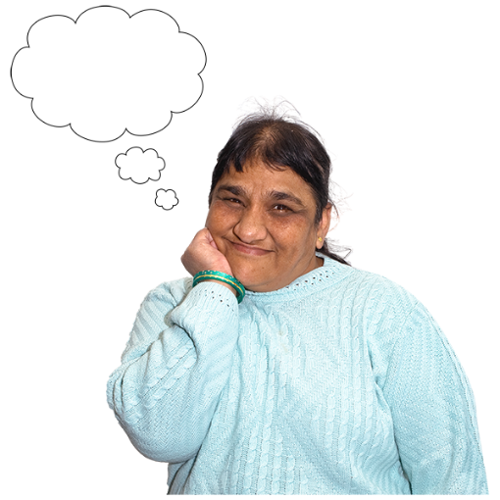
People also told us that:
it is not always clear what things they can do to make things better
problems that are not serious enough to go to court are not always dealt with.

People also told us that they can find it hard to have their problems heard if they do not:
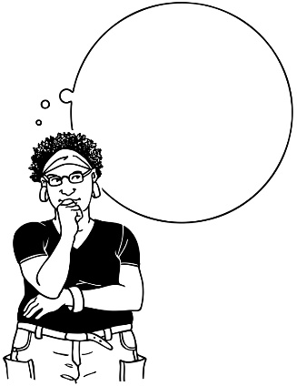
have the money to go to court
know how to go to court.

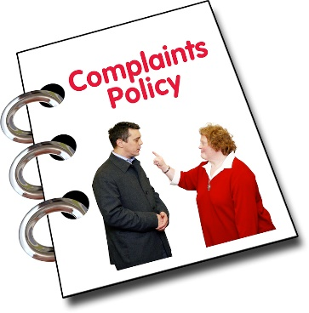
Some other ways to deal with complaints could be:
having an organisation that deals with complaints
having ways of dealing with complaints outside of court like:
- mediation
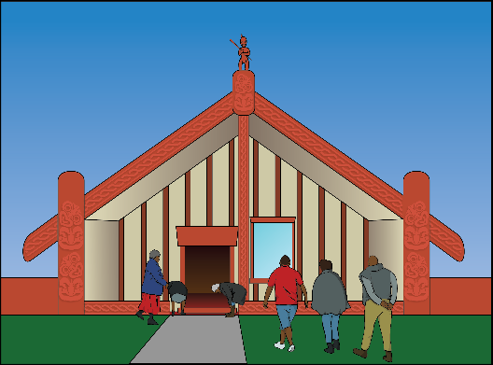
- ways of doing things that fit tikanga.

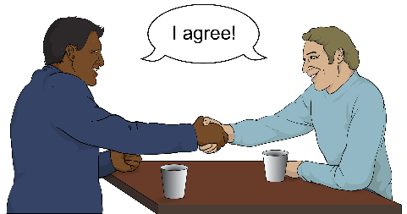
Mediation is when people have support to:
talk through a problem
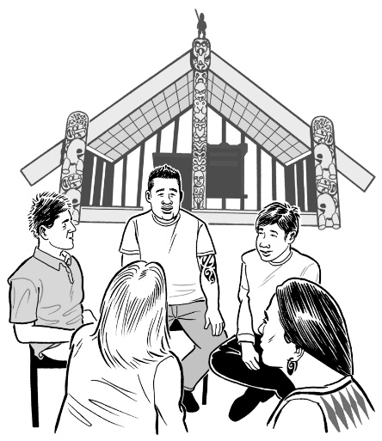
come to an agreement themselves.

Tikanga is the right way of doing things in te ao Māori / the Māori world.

Another way to deal with complaints is making how courts work:
more accessible
easier for people to use.

Question 4.2

What ways should there be for problems to be raised if things are not going well?

Other ways to make things better
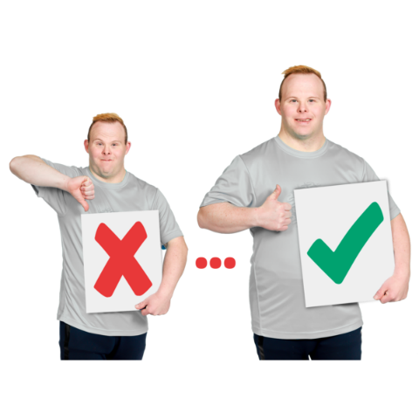

We are thinking about other ways to make things work better.

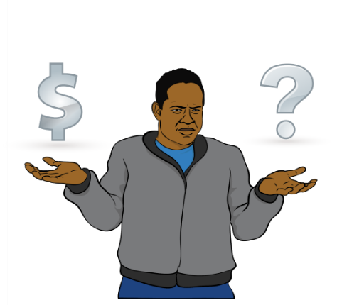
One idea is to have services for setting up decision-making arrangements that are:
free
do not cost much.

Another idea is to have a group of:
supporters
representatives
lawyers

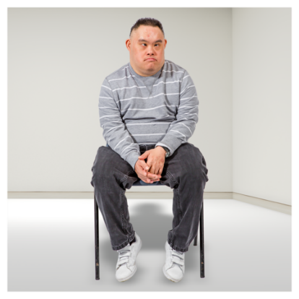
This group would be for people who do not have other people like family members to be supporters / representatives.

We are also thinking who should be in charge of making things better.

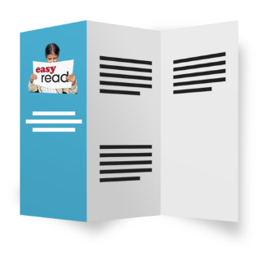
In some countries there is 1 public body that does things like:
giving information
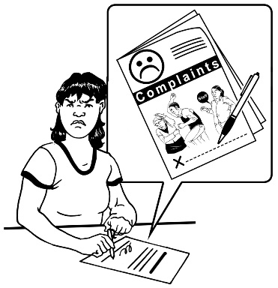
dealing with complaints
checking how decision-making arrangements are working.

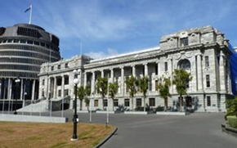
A public body is like an organisation which is paid for by the government.

Having 1 public body in Aotearoa New Zealand might make:
things work better
it easier for people to know where to go to do things like:
- get information
- make a complaint.

Starting new public bodies also:
costs money
can take time.

It might be better to work on making the organisations / way of doing things we have now better.

Question 4.3

How do you think we can make things work better?

Making how courts work easier for people

People find going to court can be very hard.

Court hearings can:
cost a lot of money
take a lot of time
be stressful
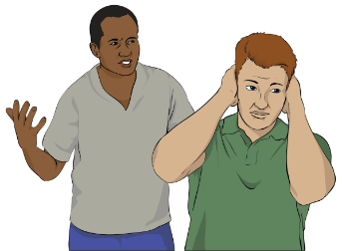
cause problems with relationships.

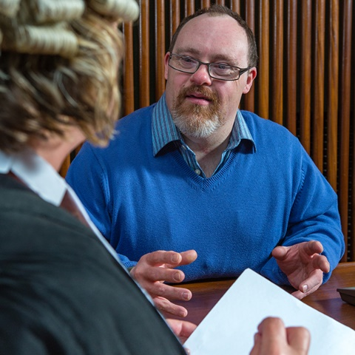
Court hearings are when a court:
listens to what people have to say
decides something.
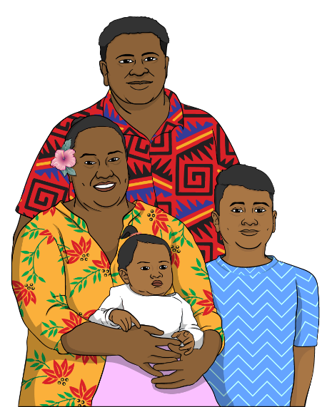
Relationships are links you have with people like:
spouse or partner
whānau / family members
friends.
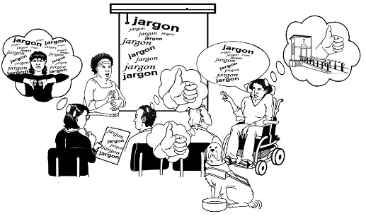

The way courts work is not accessible to everyone.

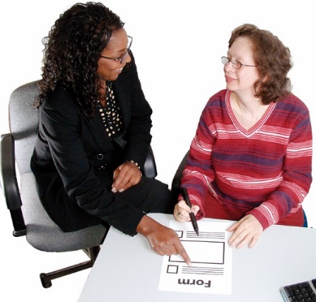
Adults with affected decision making are sometimes not given enough support to:
understand what is happening in court
be part of what is happening in court.

1 idea for making courts work better is to have better support for people with affected decision making to be part of court hearings.

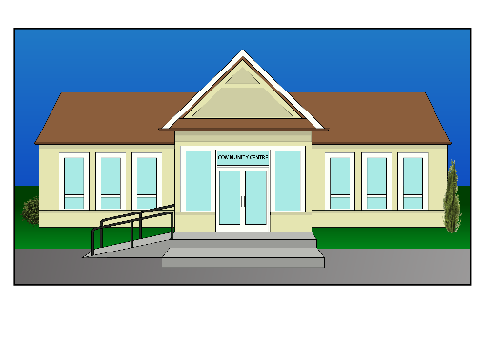
This could be by:
having hearings in different places
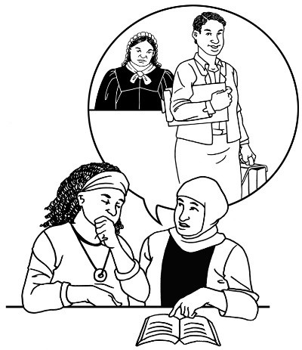
making it easier to get a lawyer who understands affected decision making well
having navigators
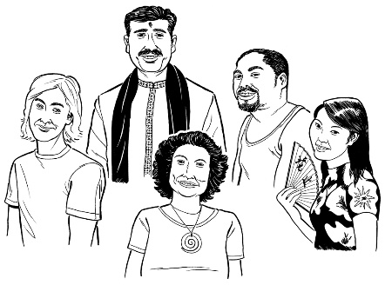
making sure the way the courts work better fits with the culture of the person with affected decision making.

Navigators support people to find their way around how courts work.
Culture is a way of:

- thinking that a group shares

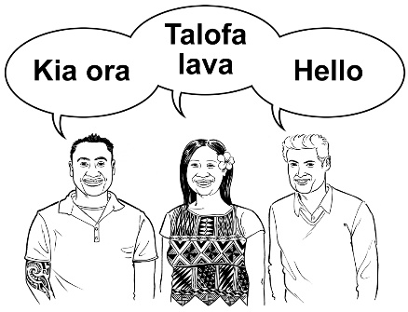
- doing things as a group.

There are many different cultures in
Aotearoa New Zealand.
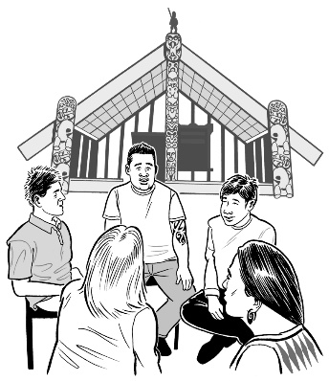

Some examples of the different cultures are:

- Māori culture
- Pacifika culture

- Deaf culture.

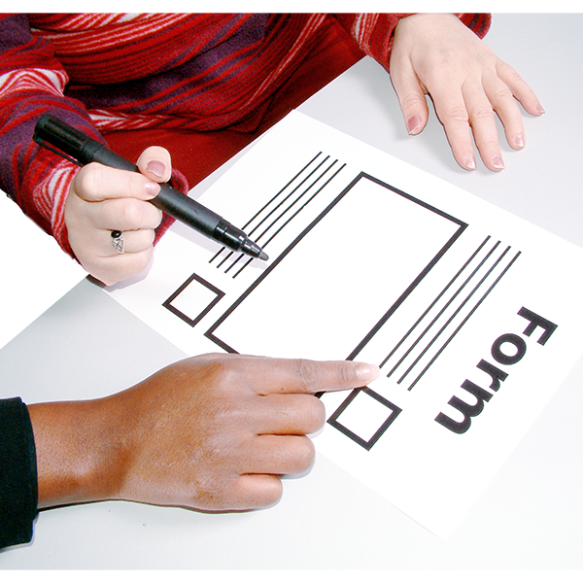
Some more ideas for making courts work better are:
making forms / information easier to use
having a particular kind of court to deal just with this sort of case.

Question 4.4

What would make it easier for people to be part of how courts deal with decision making arrangements?

Anything else you want to tell us

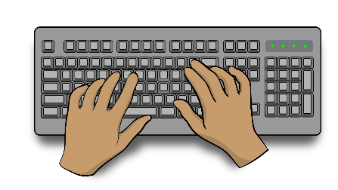
You can also tell us anything else you want to say about these topics.
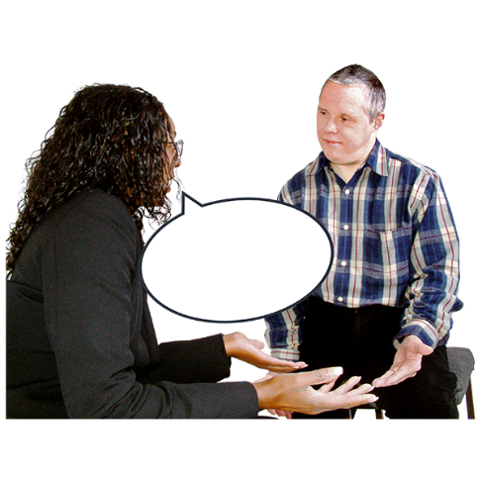

Question 4.5:

What else do you want to tell us about how things could be made better?

How to get in touch with us

You can get in touch with us by:
email at:
huarahi.whakatau@lawcom.govt.nz
phone on:
0800 832 526

If you find it hard to use the phone the New Zealand Relay service is for people who are:
Deaf / hard of hearing
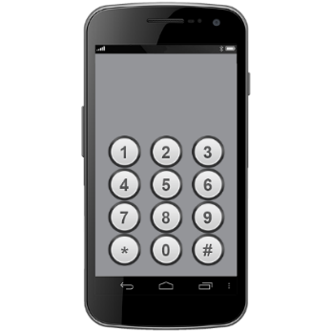
deafblind
speech impaired / find it hard to talk.

You can find out more about the New Zealand Relay service at:

www.nzrelay.co.nz

This information was written by Te Aka Matua o te Ture – Law Commission.

It has been translated into Easy Read by the Make it Easy Kia Māmā Mai service of People First New Zealand Ngā Tāngata Tuatahi.
The ideas in this document are not the ideas of People First New Zealand Ngā Tāngata Tuatahi.
Make it Easy uses images from:

- Changepeople.org

            - Photosymbols.com

- SGC Image Works
- Huriana Kopeke-Te Aho
- T. Wood.
All images used in this Easy Read document are subject to copyright rules and cannot be used without permission.

