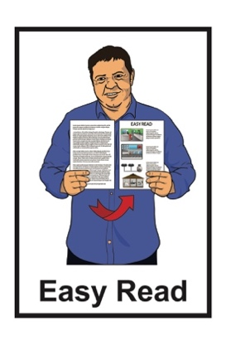

He arotake i te ture mō ngā huarahi whakatau a ngā pakeke

Review of adult decision-making capacity law
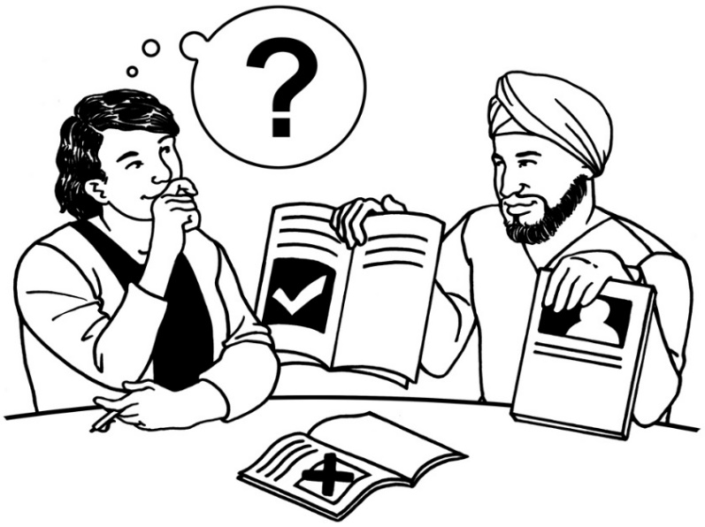

Key topics information sheet

Published: April 2024

What is in here

Page number:

What is this review? 2
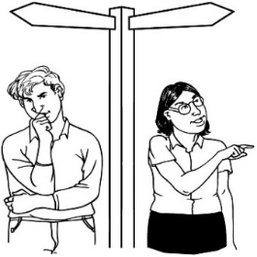

What is this review about? 4

Key topics 8

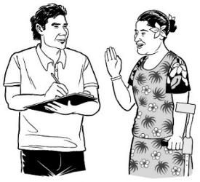
How to tell us what you think 12

If you need support 15

How we will use your information 17
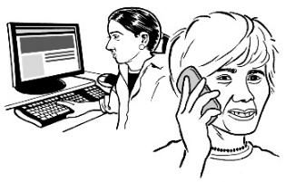

How to get in touch with us 20

What is this review?

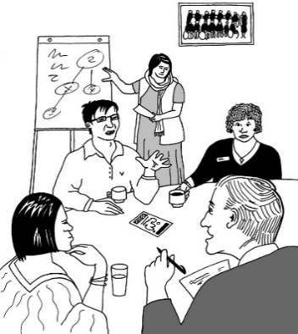
Te Aka Matua o te Ture – Law Commission is an organisation that:
- does reviews of the law
- uses what it finds out in the reviews to tell the Government how to make the law better.

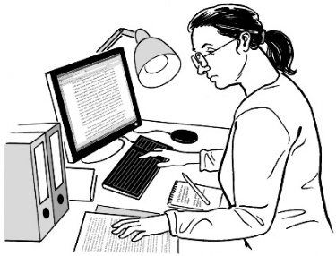
A review is when we:
look carefully at a part of the law
talk to people who know a lot of things to do with that part of the law
ask people what they think
write a report about what we have found out.

The Government does not tell the Law Commission:
how to do their work
what to say should happen.

In this Easy Read document when we say we / our this means the
Law Commission.

The Government asked us to do a review about when adults can make their own decisions.

What is this review about?

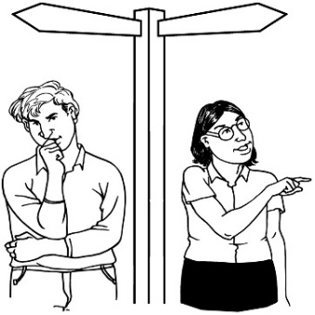
Some people find it hard to make decisions about their own lives.

In this document we will call people who find it hard to make decisions about their own lives people with affected decision making.

People with affected decision making include some people who have:
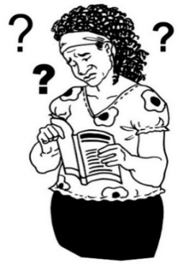
- brain injuries
- dementia
- learning disabilities.

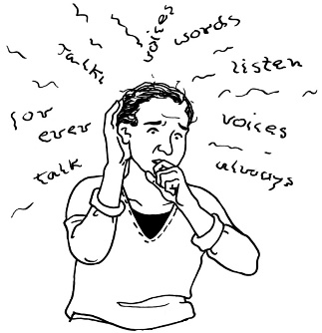
People with affected decision making include some people who have:
- experiences of mental distress
- other conditions or disabilities that affect how they make decisions.

Dementia is a health condition where people can find it hard to:
- remember things
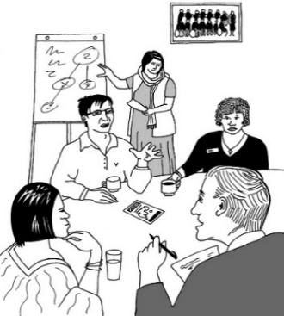
- understand things.

In this review we are looking at what the law should do when people have affected decision making.

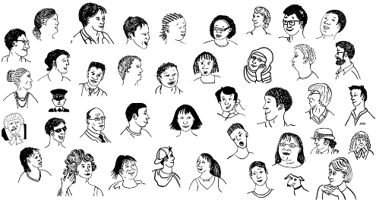
Lots of people think the law needs to change.

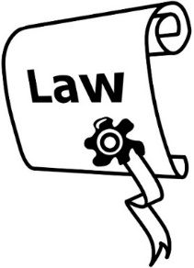
1 of the laws we are looking at is called the Protection of Personal and Property Rights Act 1988.

In this document we will call the Protection of Personal and Property Rights Act 1988 the PPPR Act.

The PPPR Act says different things that can happen if a person has affected decision making.

We think there should be a new law instead of the PPPR Act.

The new law should be more to do with what the person with affected decision making wants.

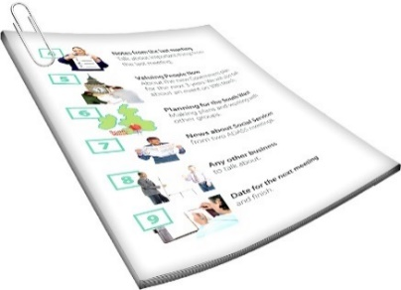
There is an Easy Read document that says what things are part of our review.

This document is called the:

Terms of Reference

You can find this document on our website at:
huarahi-whakatau.lawcom.govt.nz

Key topics

As part of this review the Law Commission wrote a document called the Preliminary Issues Paper.

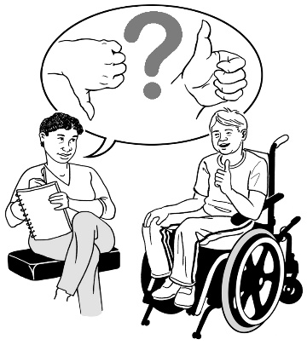
The Preliminary Issues Paper asked people what problems they have with the law as it is now.

You can find an Easy Read translation of a summary of the Preliminary Issues Paper on our website at:

huarahi-whakatau.lawcom.govt.nz

A summary is a shorter document that includes the most important information.
We used what people told us about the Preliminary Issues Paper to write the Second Issues Paper.

The Second Issues Paper:
explains problems with the law we have now
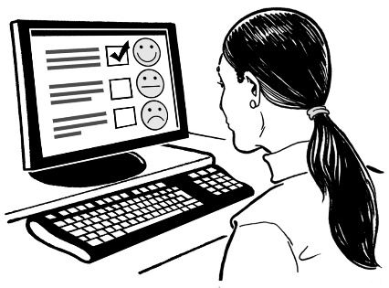
asks people to tell us how the law could be made better.

You can find the Second Issues Paper on our website at:

huarahi-whakatau.lawcom.govt.nz

The Second Issues Paper is not in Easy Read.

We have also written 4 documents called key topic documents.

These key topic documents:
talk about some of the most important things in the Second Issues Paper
ask some questions so you can tell us what you think.

The key topic documents are in:
Easy Read
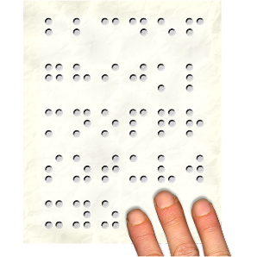
other alternate formats.

You can find them on our website at:

huarahi-whakatau.lawcom.govt.nz

The key topic documents are called:
- Key topic 1: Court-appointed representatives
- Key topic 2: Decision-making support
- Key topic 3: Enduring powers of attorney
- Key topic 4: Practical improvements and court processes.

How to tell us what you think

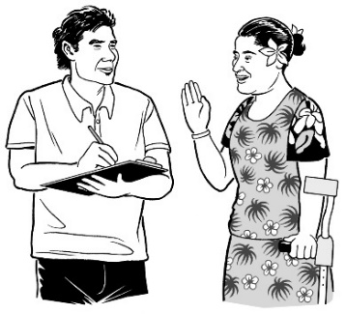
We want to hear what you think.

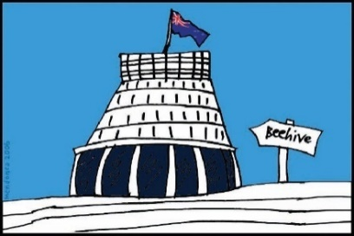
We will use what you tell us to make our report to the Government about what the law should be.

Telling us what you think is called making a submission.

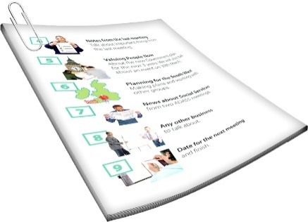
In the key topic documents there are questions about different things we will think about in the review.

When you make your submission you can answer:
- all the questions
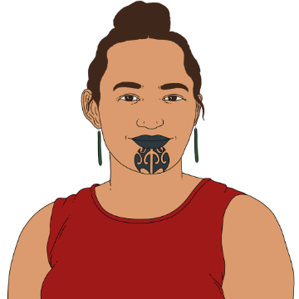
- just the questions you want to.

You can make a submission:
on your own
as part of a group.

You need to get your submission to us by:

5 pm Friday 21 June 2024.

You can make a submission by emailing us at:

huarahi.whakatau@lawcom.govt.nz
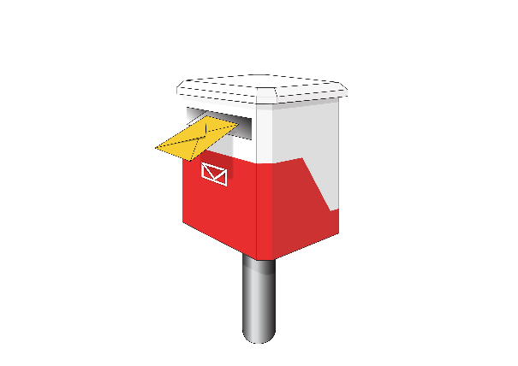
You can also post your submission to:

Review of Adult Decision-Making Capacity Law

Law Commission

PO Box 2590

Wellington 6140

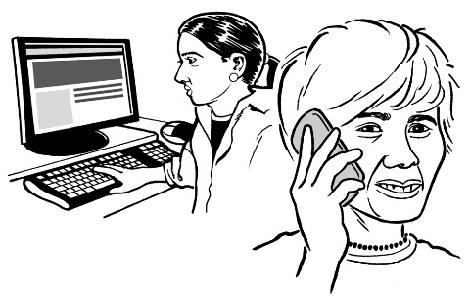
If you cannot make a submission in these ways please get in touch with us.

If you need support

Some people might find it makes them sad to:
think about the things in the review
make a submission.

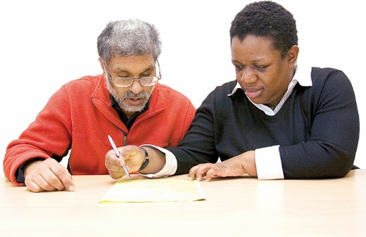
You can ask someone to support you to make a submission.

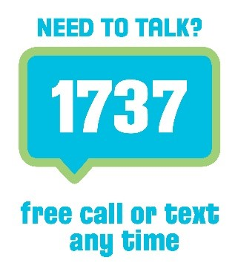
If you are upset you can also contact:

1737: Need to Talk

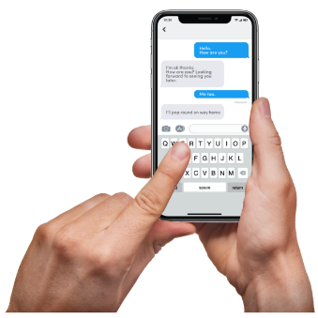
At 1737: Need to Talk you can talk to a counsellor by:
calling: 1737
texting: 1737

1737: Need to Talk is open all
day / night.

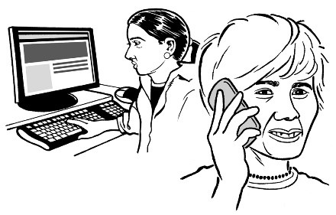
If the 1737 number does not work from your phone you can call this number:

0800 1737 1737

You can find out more about 1737: Need to Talk on this website:

www.1737.org.nz

How we will use your information

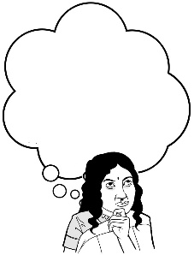
If you send us a submission we will:

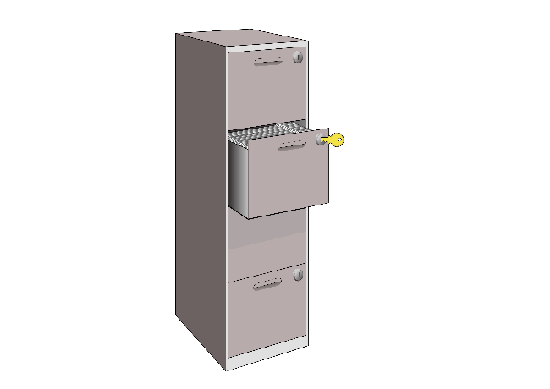
- think about what you said in your submission when we do the review
- keep the submission as part of our records.

If you send us a submission we may also:
put the submission on our website
talk about the things in your submission in things we write
think about your submission when doing other reviews.
Your submission may have personal information like your name.

You have the right to:
- see what personal information we have about you
- ask us to change any personal information that is wrong.

You can ask us not to tell anyone:
- your name
- other information that means people can tell who you are.

If someone asks us for information under the Official Information Act we have to follow the rules about releasing it.

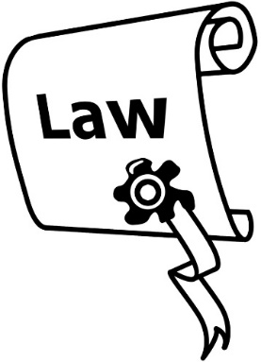
The Official Information Act is a law that lets people see information the Government has.

If the information someone is asking for includes personal information like your name then we will talk to you.

Another law we follow when using your information is the Privacy Act.

If you have questions about what we do with your submission / information you can email:
huarahi.whakatau@lawcom.govt.nz

How to get in touch with us

You can get in touch with us by:
email at:
huarahi.whakatau@lawcom.govt.nz
phone on:
0800 832 526

If you find it hard to use the phone the New Zealand Relay service is for people who are:
Deaf / hard of hearing
deafblind
speech impaired / find it hard to talk.

You can find out more about the New Zealand Relay service at:

www.nzrelay.co.nz

This information has been written by Te Aka Matua o te Ture | Law Commission.

It has been translated into Easy Read by the Make it Easy Kia Māmā Mai service of People First New Zealand Ngā Tāngata Tuatahi.
The ideas in this document are not the ideas of People First New Zealand Ngā Tāngata Tuatahi.

Make it Easy uses images from:

- Changepeople.org

            - Photosymbols.com

- SGC Image Works
- Huriana Kopeke-Te Aho
- T. Wood.
All images used in this Easy Read document are subject to copyright rules and cannot be used without permission.

